DERBYSHIRE FLORA GROUP NEWSLETTER

EDITED: ALAN WILLMOT (County Recorder)

Number 27 – WINTER 2017/2018

1. EDITORIAL
I include in this newsletter an overview of new and interesting plant records for last year. There is a review of our local plant recording with an appeal for help in concluding our contribution to the new national Atlas. There are also details of the outdoors meetings for this year. In this programme meetings are directed towards completion of the new Atlas and visiting botanically interesting areas.

2. RECENT PLANT RECORDS vc57
As in previous years these are mainly reports of newly established aliens. However, there are also a number of reports of plants that we should consider native as they probably arrived here spontaneously even if some arrivals were with the help of traffic movements.

Acer tataricum ssp. ginnala (Amur Maple) This is a small tree which is sometimes grown in gardens as an ornamental. I found a single tree growing on the restored tip at what is now Nutwood Reserve (SK3538) in June 2017. It is unlikely this was planted as part of a restoration scheme as it is on its own so it is most likely to have established itself from garden waste. It is a first county record and a casual.

Adiantum capillus-veneris (Maidenhair Fern) This fern was found growing in mortar under a railway bridge at Bullbridge (SK3552) by Claire and Mary Smith during July 2017. It normally grows wild in the milder coastal climates of south-western Britain, so it was unusual to find it growing so luxuriantly in central Derbyshire. This was only our second county record, probably established from garden or conservatory material.

Allium paniculatum ssp. fuscum (Pale Garlic) This was found growing just inside a field gate off Screetham Lane, Beeley Moor (SK3066) in August 2017 by Mick Lacey, and confirmed by Paul R. Green. Naturalised on roadsides in the West Country and native to south-east Europe, it is probably a casual from garden waste with us.

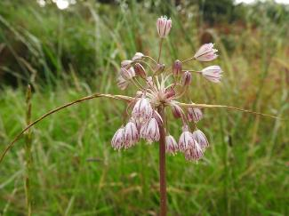

Allium paniculatum Beeley Moor (M Lacey)

Anacamptis morio (Green-winged Orchid) One plant of this native orchid was found growing at Hartington Meadows (SK1561) by Christine Hobson and Susan Freestone in late May 2017. This is only the fourth record since 1987, all of which were for odd plants growing amongst or near large populations of Orchis mascula (Early-purple Orchid). This suggests people may be overlooking the rare odd plants of the Green-winged Orchid as just another Early-purple Orchid.

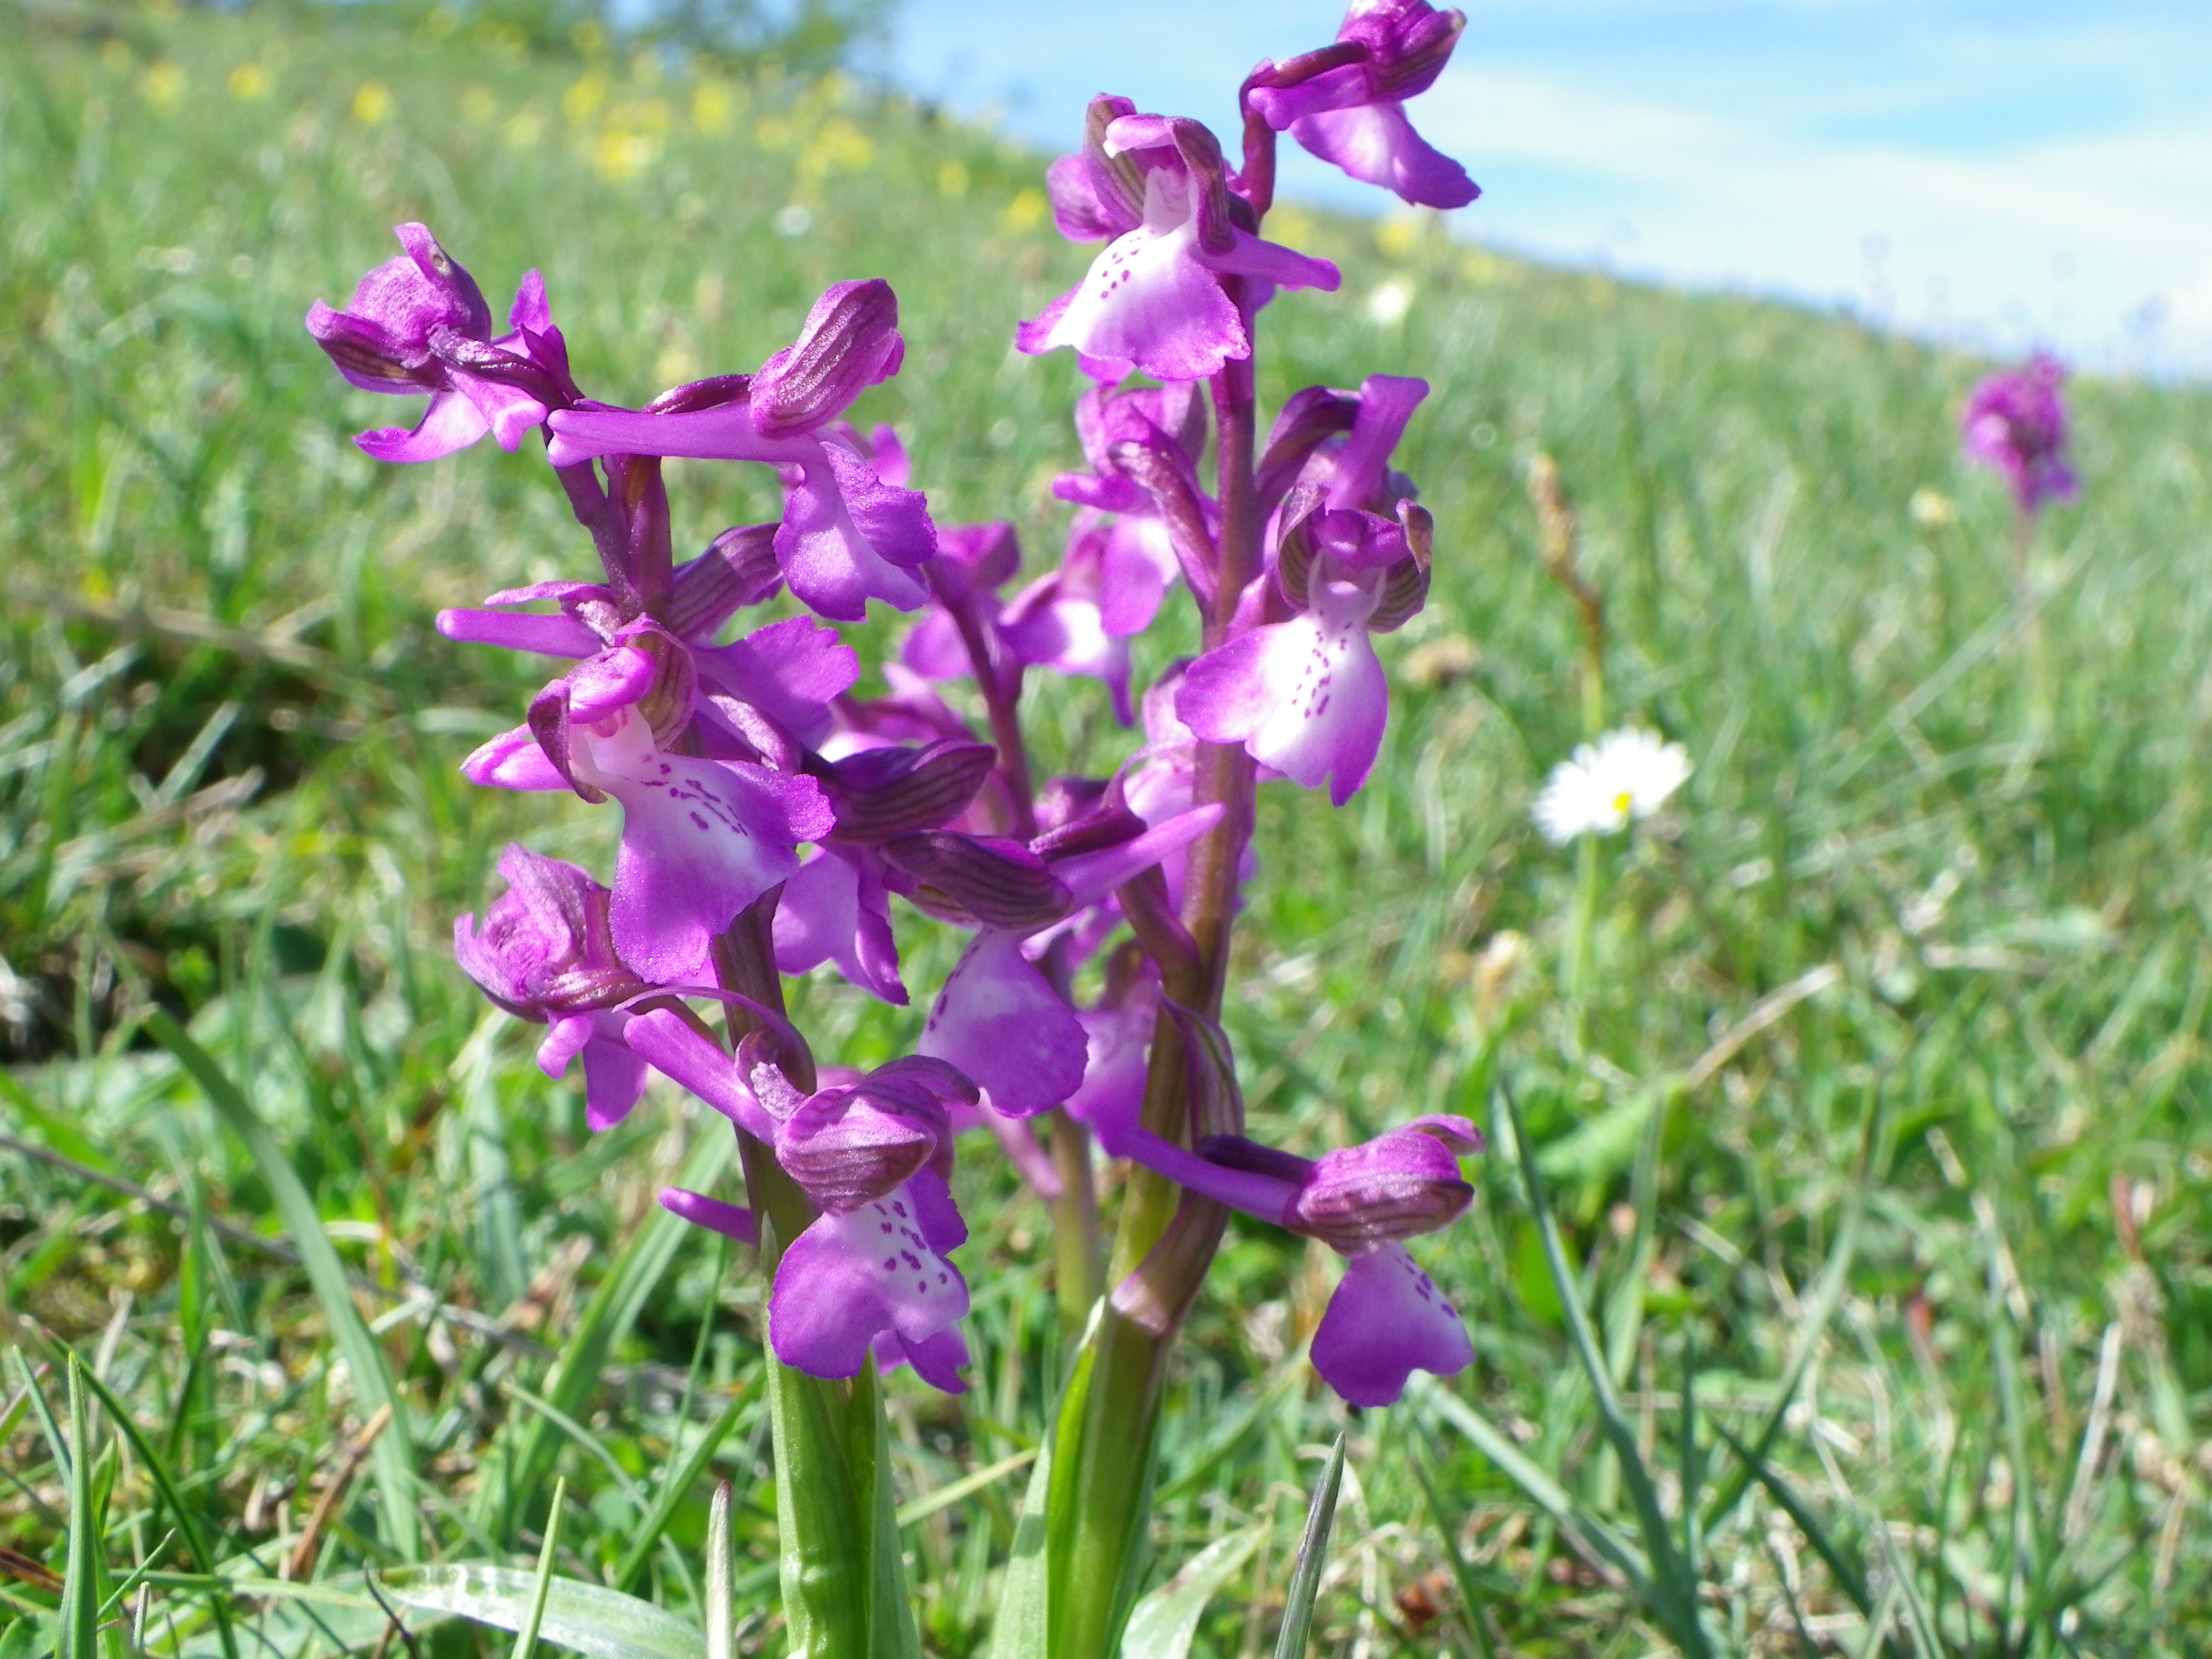

Anacamptis morio Middleton 2013 (M Lacey)

Berberis x stenophylla (Hedge Barberry) This hybrid arose around 1860 in a garden near Sheffield and is now commonly planted in landscaping and restoration schemes. It was found by Brian Gough in Cuckoostone Quarry (SK3162) on one of our wetter Flora walks in September 2017. It was probably a remnant of a garden planting and it is a first county record for us.

Catabrosa aquatic (Whorl-grass) This native grass was recorded by myself growing in Shirley Brook just inside Shirley Park (SK2141) in June 2017. This was only the fourth record since 1987 but it is probably under-recorded as unless flowering it looks like any other emergent grass of watersides.

Catapodium marinum (Sea Fern-grass) This small annual grass was found by the side of the A6 near Ripley (SK3851) by Claire and Mary Smith in July 2017. It is native on bare ground near the sea in Britain but is also a member of the salt-tolerant roadside flora of inland roads subject to salt de-icing. Officially recorded as casual in the county, it has no doubt arrived here spontaneously swept along in the slip stream of traffic from the coast. This first county record should be looked for elsewhere. It looks like a diminutive plant of Lolium perenne (Perennial Rye-grass) rather than its commoner cousin Catapodium rigidum (Fern-grass).

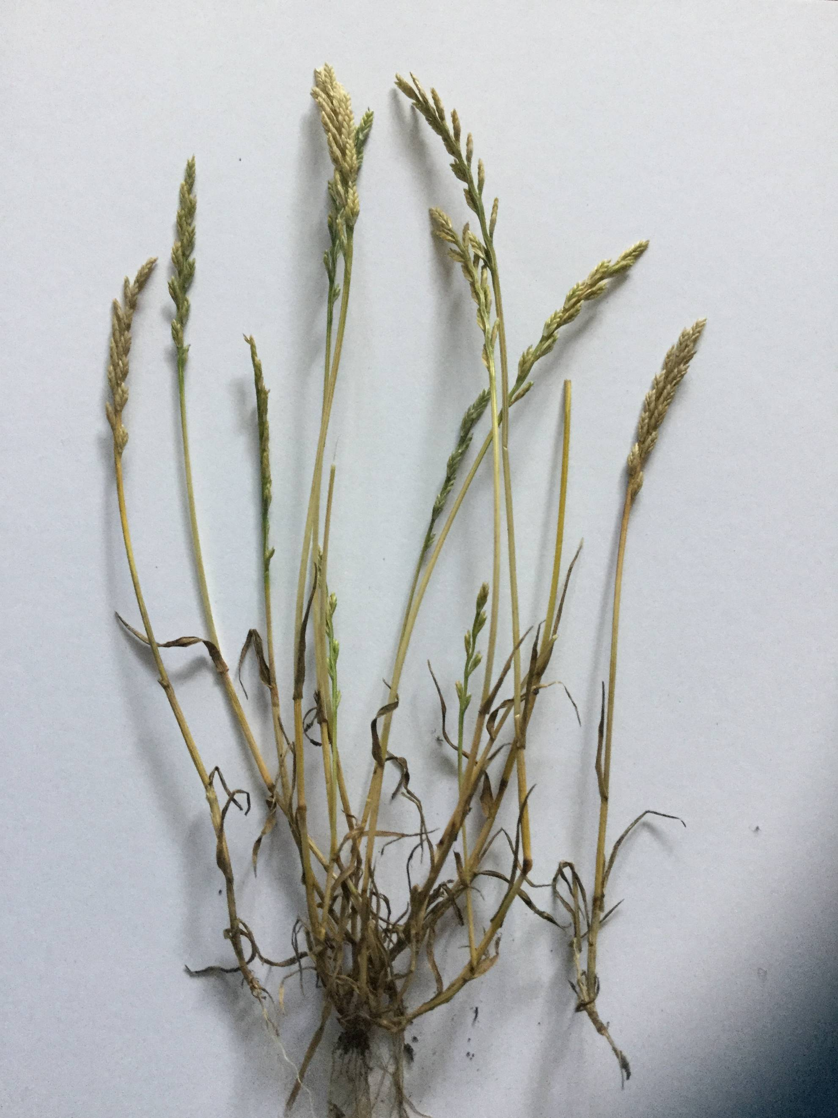

Catapodium marinum from A6 near Ripley with C. rigidum (C Smith)

Cerastium diffusum (Sea Mouse-ear) A depauperate specimen of this very low-growing plant of bare ground was found by Mick Lacey in April 2017 in the lay-by near Clay Cross on the A61 (SK3964). This was the first record this century and only the fifth since 1987. Despite the common name this species does not seem to be a member of the salt-tolerant flora of inland roads subject to salt de-icing.

Cotinus coggygria (Smoke-tree) A plant of this was found at the bottom of a Beech hedge by Brian Gough in the car park near Sainsbury’s at Matlock (SK2960) in August 2017. Recorded as casual now, this first county record probably arrived as a contaminant of the Beech plants used to form the hedge.

Crataegus persimilis (Broad-leaved Cockspurthorn) One tree of this was recorded as growing in Nottingham Road Cemetery (SK3736) by myself in June 2017. Probably planted originally, it appears to be thoroughly naturalized at the site now though it can only be recorded as casual at present as it has not been observed for the requisite five years. This is another first county record.

Cuscuta campestris (Yellow Dodder) In September last year Nick Brown sent me a photo of what he thought was Yellow Dodder growing under a bird table in Kirk Langley (SK2937). This was the first county record for a plant which is introduced from North American and which is normally found here growing on crops especially carrots. On further investigation it turned out that the Dodder was growing on Niger (Guizotia abyssinica). The Dodder was probably introduced here with bird seed.

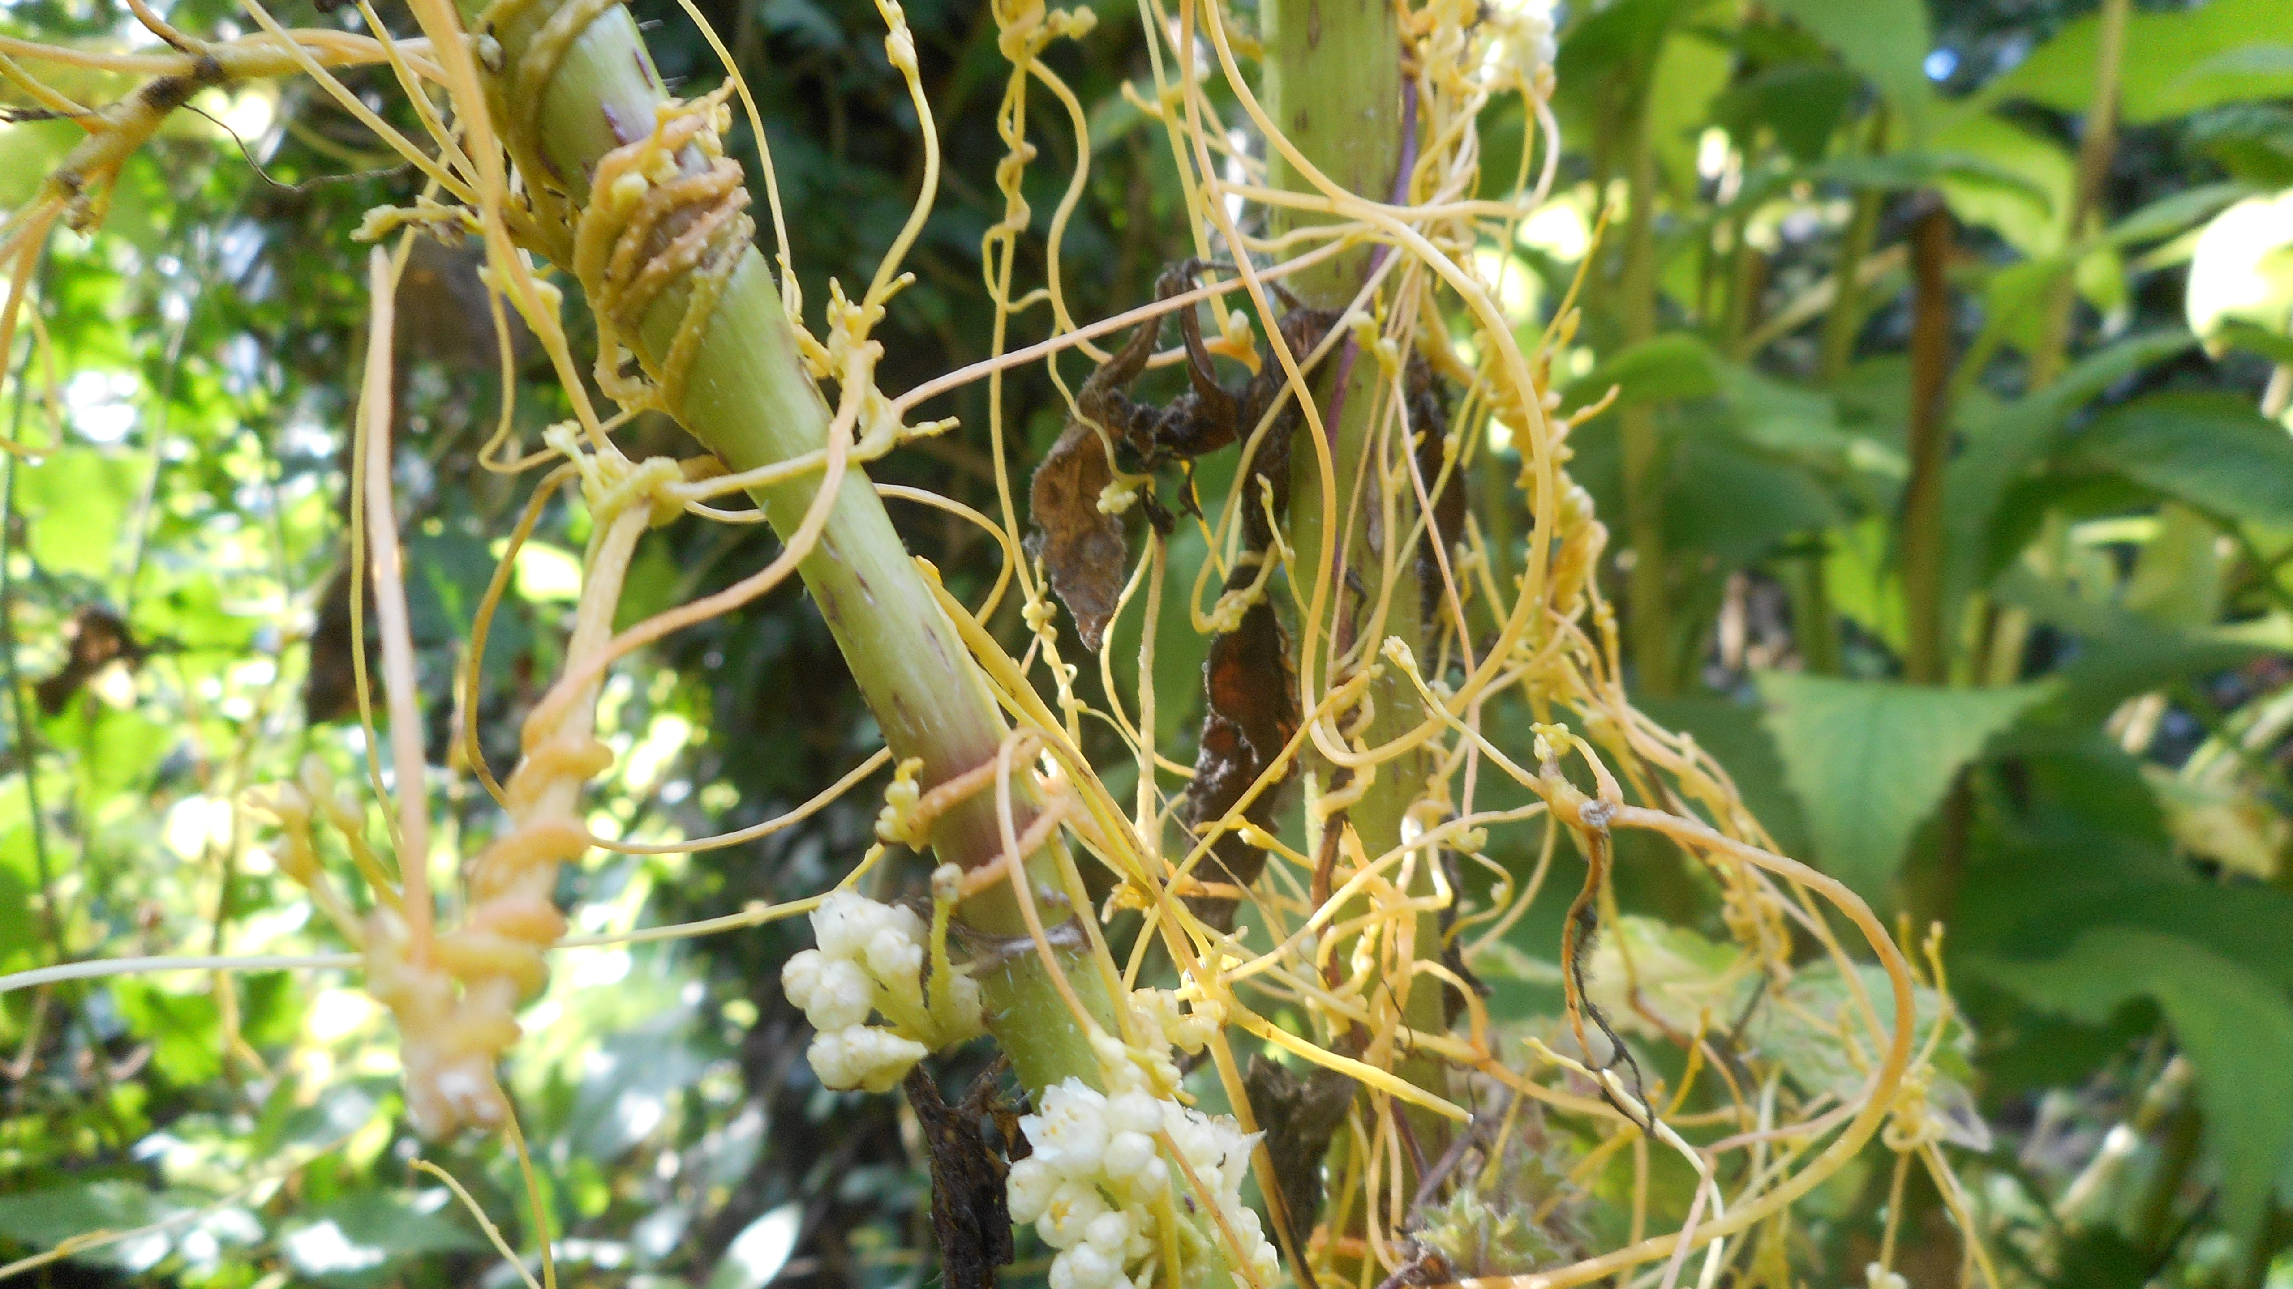

Cuscuta campestris Kirk Langley (N Brown)

Epipactis dunensis (Dune Helleborine) In August last year Mick Lacey sent me a photo of an orchid growing in Derbyshire which was soon confirmed by Prof. J. Richards as this plant and which is a first county record. The discoverer of the plant had seen it at the same site in 2004 and so the plant must be accepted as at least established in the county. Elsewhere in the country it often occurs naturally on heavy-metal-polluted soils, this suggests the plant may in fact be native to our county but simply overlooked before. Alternatively, the seeds may have been introduced with equipment imported from another mining area.

Eucalyptus genii (Cider Gum) A small well-established and apparently self-sown tree of this Tasmanian species was recorded by Gareth Herons on waste ground in Yateley village (SK1840) in July last year. This is the first county record for this the hardiest of Eucalyptus species in this country.

Euphorbia graffiti (Griffith’s Spurge) Brian Gough found a specimen of variety Foreglow of this garden ornamental off Painters Lane, Winster (SK2460) in October last year. This first county record was probably a garden escape or throwout.

Gnaphalium luteoalbum (Jersey Cudweed) Mick Lacey reported a stand of this garden ornamental growing on a pavement in Hady Lane, Chesterfield (SK4070) in July 2017.
It occurs naturally in the south and east of England but as this is its first record in the county and it has only be known on the site for a year, it must be regarded as only casual here.

Hemerocallis fulva (Orange Day-lily) This is yet another first county record and garden escapee or throwout recorded by Brian Gough. He recorded it in the Matlock Quarry area (SK2960) in August last year.

Hieracium subprasinifolium (Leek-coloured Hawkweed) The rediscovery of this native Hawkweed in Chee Dale (SK1172) last June by Tim Rich caused quite a stir in the media both locally and nationally. He came to collect seed of the plant for the Kew Millennium Seedbank. It had been last been recorded in Derbyshire in 1954. It had probably not been seen since as nobody capable of identifying the plant had been there in the intervening years.

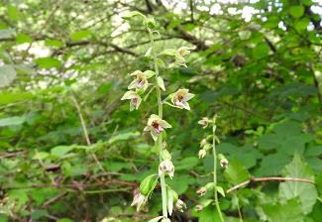

Epipactis dunensis vc57 2017 (M Lacey)

Lavandula angustifolia (Garden Lavender) This was found growing out of a garden wall on Main Street, Wensley (SK2661) by Brian Gough in April last. Surprisingly this is our first county record for such a common garden plant. However, this western Mediterranean undershrub generally finds our climate too wet than to be anything other than, as here, a casual introduction.

Nemesia strumosa (Nemesia) This annual from South Africa is commonly grown in English gardens as an ornamental but it rarely occurs as a casual with us. However, Mick Lacey made a first county record for this plant as a street weed outside the HSBC in Belper (SK3447) on Christmas Eve 2017. The plant was only in bud then and it is not known if it survived the cold weather around Christmas to actually flower and thus have a chance of establishing itself locally.

Nerine sarniensis (Guernsey Lily) Mick Lacey found several plants of this growing as a casual on abandoned allotments at Hodthorpe (SK5476) in October last year. Despite its name this is another introduction from South Africa. This is also a first county record for us.

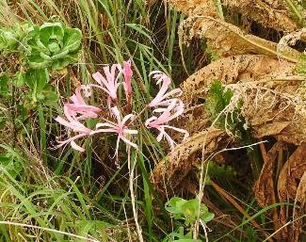

Nerine sarniensis Hodthorpe (M Lacey)

Parthenocissus tricuspidata (Boston-ivy) Marion Bryce recorded this growing as a casual on Erewash Canal (SK4832) in July 2017. This is only the second record for the county, the other having been made in 1960.

Phuopsis stylosa (Caucasian Crosswort) This attractive garden ornamental was found growing as a casual on a rough bank at Church Farm Drive, Sandiacre (SK4737) by Marion Bryce in September 2017. It had probably spread from plantings in the adjacent churchyard. For once the name of the plant accurately describes its geographical origins. This is yet another first county record.

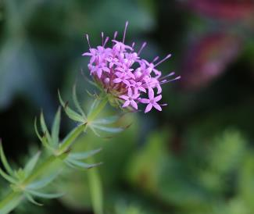

Phuopsis stylosa Sandiacre (M Bryce)

Physalis philadelphica (Large-flowered Tomatillo) This close relative of the Japanese-lantern (P. alkekengi) was found as a casual weed in a potato crop at Oxcroft Lane, Bolsover (SK4770) by Mick Lacey in August 2017. This is the first record for this plant in the county.

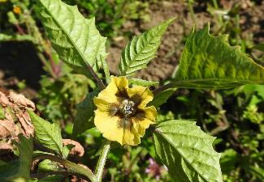

Physalis philadelphica Bolsover (M Lacey)

Rumex patientia (Patience Dock) A single plant of this was found by Gareth Hirons as a weed in a shrubbery at Howard Mills, Glossop (SK0394) in October 2017. Although only a casual with us, it is well established elsewhere in England particularly the London area. This is a first record for the county.

Silene gallica (Small-flowered Catchfly) Roy Frost reported this from The Avenue, Chesterfield (SK3968) in June 2017. Although this is the first local record since 1982 and only the fifth ever, it is possible that this should be regarded as a native locally due to its natural occurrence in adjacent counties.

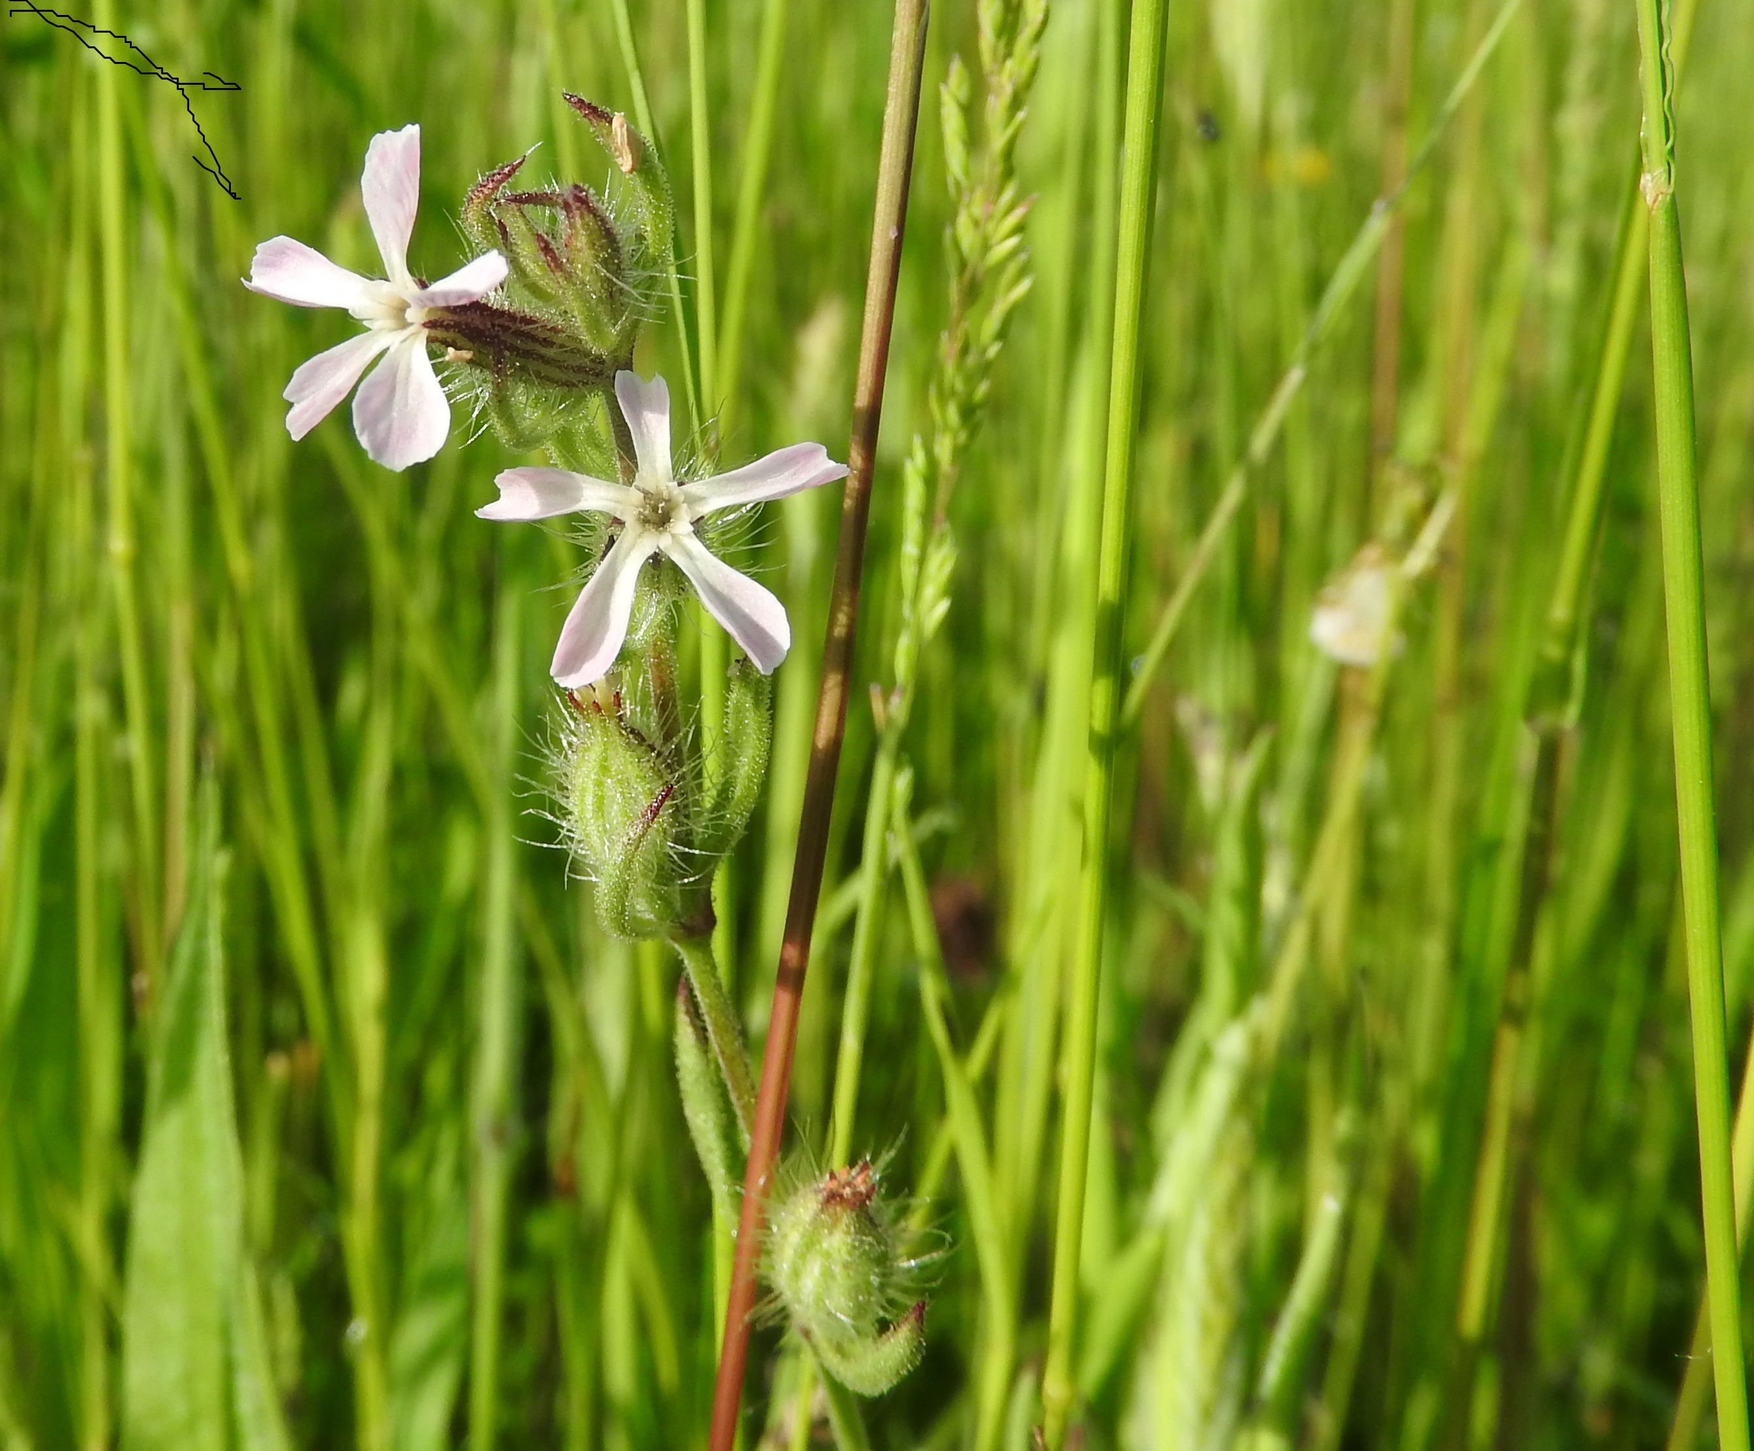

Silene gallica The Avenue (M Lacey)

Symphytum caucasicum (Caucasian Comfrey) Claire and Mary Smith made a first county record for this at Charlesworth Stud, Woodseats Road (SJ9992) in April last year. Only casual when recorded, it is unlikely to become naturalized as it rarely persists outside in England.

Tanacetum macrophyllum (Rayed Tansy) Another first county record for Claire and Mary, this time from the banks of the River Derwent at Cromford (SK2957) in June last year. It is a garden ornamental from south-eastern Europe. Generally, a casual garden escape or throwout, it may have been spread here by the river.

Urtica dioica ssp. galeopsifolia (Non-stinging Common Nettle) Although recorded at the pumping station on the Cromford Canal (SK3255) by Claire and Mary in August 2017 as a first county record, this native plant has been undoubtedly overlooked for many years. Apart from the lack of stinging hairs, this subspecies can be recognised by its longer narrower leaves. It usually grows in wetter places away from the weedy situations of the usual subspecies.

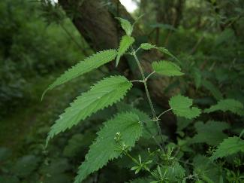

Urtica dioica ssp. galeopsifolia

Viola x contempta (A hybrid pansy) This cross of Wild Pansy (V. tricolor) and Field Pansy (V. arvensis) was recorded by Mick Lacey at Markham (SK4573) in May last year growing amongst a population of the Wild Pansy. This is the first record since Clapham’s 1969 Flora where only three records are given.

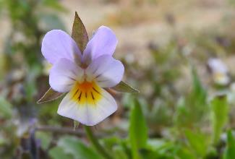

Viola x contempta Markham (M Lacey)

3. PROGRESS WITH LOCAL RECORDING

As with the last couple of years, I concentrated us this year on recording for the new national Atlas to be published in 2022. To assess progress with this I will continue to use the traffic light scheme for hectads devised by the BSBI. This is based on two criteria; one for tetrads within a hectad and one for total hectad plant diversity. Firstly, a hectad is considered resurveyed if 5 of the 25 tetrads in the hectad are considered resurveyed. A tetrad is considered resurveyed if 75% of the plants ever recorded in the particular tetrad have been seen there in the time period 2000 – 2019. As we are only concerned with Derbyshire, the number of required tetrads is reduced for hectads that include parts of neighboring counties. Secondly, a hectad is considered resurveyed if 75% of the plants ever recorded in the hectad have been seen there in the time period 2000 - 2019. Hectads that reach neither criterion are colored red in the traffic light scheme. If they satisfy only the tetrad criterion, they are colored yellow and if the satisfy both criteria they are colored green.

Last year of the 42 hectads that are wholly or partly in Derbyshire (vc57), two were red, 24 yellow and 16 green according to the traffic light scheme. I am pleased to say that this year there are no red hectads left and only 18 yellow ones with 24 green completed hectads (See attached diagram). I feel therefore we have made significant progress over the year. Further details of the current hectad status are given in the attached diagram, where the total hectad percentage refind is given for each of the yellow hectads. I have also indicated here with a P those hectads which I consider are priority for Derbyshire as they are wholly or mostly in the county.

RECORDING PRIORITIES FOR 2018

I am happy to receive plant records for any parts of the county but would like people as a priority to consider recording in any of the yellow hectads particularly those marked with a P. To help with this I have calculated the number of refinds that need to be made in each hectad based on the current percentage refind and total number of species recorded for all years (See attached table). Take hectad SK26 for example, here we currently have a 74% refind and a total species recorded for all years of 1,136. We therefore need to refind a further one percent of species which means around 12 species. To further help with refinding plants, I can provide for each hectad a list of the plants recorded there but not recorded since 1999. I should stress that both new plants and refinds will count in the total percent refind score. However, as any such new plants also increase the total number of plants ever recorded in the hectad, more of these are needed than the number of refinds to reach the 75% required.

4. OUTDOOR MEETINGS 2018
I have organised a series of outdoor meetings in Derbyshire on the same basis as previous years that is I have included some suggestions from others, some areas that need recording for the new Atlas and some areas just to see interesting plants.

5. ENQUIRIES
Any enquiries concerning the identification and recording of higher plants in Derbyshire can be made to me at my address below.

Distribution maps and draft species accounts produced some years ago, can still be viewed on the website of Derby City Council at www.derby.gov.uk/flora . Please note however that these are now many years out-of-date. If you require more recent information, you can refer to our Flora of Derbyshire which was published in 2015 by Pisces Publications. Copies of which I still have available for sale at the pre-publication price.

Dr Alan Willmot
2 Kedleston Close Allestree
Derby DE22 2RA
Tel. 01332 550373
Mobile (used on field trips) 0794 121 4977
E-mail alanwillmot@outlook.com
 | SJ99 | SK09 | SK19
 | SJ98 63% | SK08 69% P | SK18 | SK28 72% | SK38 | SK48
 |  | SK07 71% P | SK17 | SK27 | SK37 | SK47 | SK57
 |  | SK06 74% | SK16 | SK26 74% P | SK36 | SK46 | SK56 71%
 |  |  | SK15 72% P | SK25 | SK35 | SK45
 |  |  | SK14 63% P | SK24 69% P | SK34 | SK44
 |  | SK03 | SK13 74% P | SK23 72% P | SK33 72% P | SK43 | SK53
 |  |  | SK12 64% | SK22 71% P | SK32 71% P | SK42
 |  |  | SK11 69% | SK21 72% P | SK31
HECTAD STATUS FOR 2020 ATLAS AS AT 7th JANUARY 2018
 |  | With percentage refinds for yellow squares
 |  | P | Priority hectad for Derbyshire
 |  |  | Hectads with the required number* of well recorded
 |  |  | tetrads* but less than 75% of species refound.
 |  |  | Hectads with the required number* of well recorded
 |  |  | tetrads* and 75% of species refound.
 |  |  |  | *Five well recorded tetrads are required for a
 |  |  |  | complete hectad but fewer for a marginal one.

Hectad | Number of plants recorded all years | Total percent refind so far | Percent needed for 75% | Exact number of refinds required | Rough number of refinds required
SJ98 | 594 | 63% | 12% | 71.28 | 72
SK06 | 618 | 74% | 1% | 6.18 | 7
SK07 | 1027 | 71% | 4% | 41.08 | 42
SK08 | 849 | 69% | 6% | 50.94 | 51
SK11 | 179 | 69% | 6% | 10.74 | 11
SK12 | 188 | 64% | 11% | 20.68 | 21
SK13 | 718 | 74% | 1% | 7.18 | 8
SK14 | 996 | 63% | 12% | 119.52 | 120
SK15 | 889 | 72% | 3% | 26.67 | 27
SK21 | 788 | 72% | 3% | 23.64 | 24
SK22 | 914 | 71% | 4% | 36.56 | 37
SK23 | 777 | 72% | 3% | 23.31 | 24
SK24 | 1032 | 69% | 6% | 61.92 | 62
SK26 | 1136 | 74% | 1% | 11.36 | 12
SK28 | 855 | 72% | 3% | 25.65 | 26
SK32 | 1021 | 71% | 4% | 40.84 | 41
SK33 | 1081 | 72% | 3% | 32.43 | 33
SK56 | 721 | 71% | 4% | 28.84 | 29

Table of Number of Refinds Required per Hectad

DERBYSHIRE FLORA GROUP |  |  |  |  | OUTDOOR MEETINGS 2018
All meetings are held on Saturdays & start at 10.30 am. They usually end by 4.30 pm. Carry lunch.
Date | Month | Venue |  |  | Meeting Point & Reason
24th | March | Robin Wood |  |  | Meet on side of A514 at SK365250 for general flora of hectad SK32 leader Alan Willmot
21st | April | Haywood |  |  | Meet in NT car park at SK255777 for woodland flora leader Alan Willmot
19th | May | Wye Dale |  |  | Meet in car park at SK104725 for woodland flora leader Alan Willmot
16th | June | Pleasley Country Park |  |  | Meet in car park at SK499642 for general flora and particularly Dactylorhiza orchids leaders Ken Balkow and Loz Brooks
7th | July | Upper Dovedale |  |  | Meet in Milldale car park at SK136547 for general flora of hectad SK15 leader Alan Willmot
28th | July | Hollingwood |  |  | Meet in car park at SK415745 for flora of canal and brownfield sites leader Ken Balkow
18th | August | Buxton |  |  | Meet on Lightwood Road at SK055747 for general flora of hectad SK07 leader Steve Orridge
8th | September | Goyt Valley |  |  | Meet in car park at SK024752 for general flora of hectad SK07 leader Alan Willmot
29th | September | Bowden Bridge |  |  | Meet in car park at SK048869 for general flora of hectad SK08 leader Alan Willmot
N.B. some of these meetings start from pay & display car parks where change is not usually available.
Meetings organiser: Dr Alan Willmot |  |  |  |  | Mobile on day: 0794 121 4977
 | Home: 2 Kedleston Close, Allestree, Derby, DE22 2RA. Tel. 01332 550373.
 | Email: alanwillmot@outlook.com
Anyone interested in botany is welcome to come on these meetings but please contact the organiser
if you have not attended one of the events before.
 |  |  |  |  | 11th January 2018
- Willmot |  | Floravc57/Meetings/Meets2018 Final

