DERBYSHIRE FLORA GROUP NEWSLETTER

EDITED: ALAN WILLMOT (County Recorder)

Number 26 – WINTER 2016/2017

1. EDITORIAL
I have included in the edition sections on new Conyza species, recent plant discoveries and progress with recording for the new national plant atlas. Please note appeal in the latter section for help in completing the local recording here. I end with details of this year’s outdoor programme.

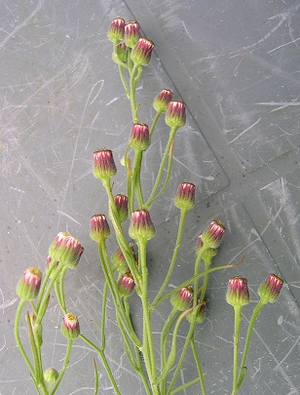

Conyza bonariensis New County Record for Derbyshire in 2016 (see section 3) Photo AW.

2. RECENT PLANT RECORDS vc57
There seems to have been a spate of new county records this year, most are of introduced or escaped garden plants but at least one maybe an old native species for the county which has been previously overlooked.

Acaena novae-zelandiae (Pirri-pirri-bur) The second county record for this low-growing perennial was found on the Longdendale Trail (SK110998) on our Flora Group meeting there last year.

Acer saccharinum (Silver Maple) David Blowers recorded one tree of this species growing on the south bank of the River Goyt (SK0085) last year. Possibly planted, it is now well established in a natural looking situation.

Alnus x elliptica (A hybrid Alder) This hybrid of our native Alder (A. glutinosa) and the introduced Italian Alder (A. cordata) was recorded on the restored Creswell Colliery (SK521733) by David Wood last year. As it arose spontaneously on the site, this first county record is considered a new native here.

Ceanothus thrysiflorus (Bluebrush) A discarded bush of this was found barely alive by Brian Gough near the children’s park at Ilkeston (SK468418) last year. Currently considered casual with us only repeated observations will tell us if this first county record establishes itself there.

Cicerbita plumieri (Hairless Blue-sowthistle) Claire Smith discovered this first county record on our Flora Group meeting to the High Peak Trail at SK158621 last year. It is a relative of the locally frequent Common Blue-sowthistle (C. macrophylla) though to my eyes it is the former which has the large leaves. In fact, when Claire first pointed it out, I thought it was a monstrous Dandelion due to its leaves.

Cotoneaster hissaricus (Circular-leaved Cotoneaster) Brian Gough recorded this as new to the county at Shipley (SK4345) last year. As the name suggest, the plant is remarkable for its round leaves.

Cyclamen coum (Eastern Sowbread) I have commented before on the spread of Sowbread (C. hederifolium) locally. This is now joined by its eastern relative which I found growing on the grass verge of the Broadway in Derby (SK340377) last year. Also, established with it was the Balkan Anemome (Anemone blanda). Clearly both had escaped from an adjacent garden and were now flowering profusely on the verge.

Cyrtomium falcatum (House Holly-fern) Claire Smith made a first county record for this introduced fern on rocks next to a mill pond near Tansley Knoll (SK318600) in March last year. I noted a second plant growing in a road drain in New Street, Bakewell (SK218686) in November.

Euphorbia stricta (Upright Spurge) This is fairly common just over the border into Nottinghamshire so it is strange that it has taken until 2016 for a record to be made of this plant locally. I found it growing apparently well-established on the disturbed grass verge of a layby on the west side of the A608 near Morley (SK398423).

Hedera algeriensis (Algerian Ivy) I recorded this growing for the first time in the county at Norbury Wood (SK128424) in March last year. No doubt originally planted as an ornamental, it is now well-established there.

Helleborus orientalis (Lenten Lily) Claire and Mary Smith found this introduced species for the first time in Derbyshire in woodland above the River Derwent near Froggatt (SK244760) in March last year. There were two plants both in flower.

Juncus foliosus (Leafy Rush) Claire and Mary Smith also made this the second record for this Rush in Derbyshire. They found it by the stream near the old mill in Chatsworth Park (SK258688) last year. This was just where David Dupree made his original discovery twenty years before. This species looks very like the common Toad Rush (J. bufonius) but has dark stripes on its petal like tepals.

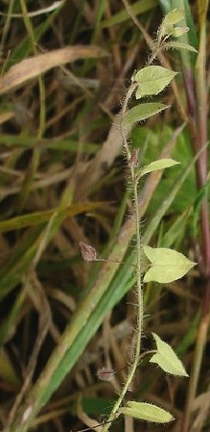

Kickxia elatine Swanwick Junct. In 2015 Photo S Jackson.
Kickxia elatine (Sharp-leaved Fluellen) Like most weeds of arable crops this diminutive weed has all but died out locally due to agricultural improvements. However, I found it last year thriving in the beds of herbs at Weleda’s growing ground at Shipley (SK448447). Other arable weeds of note growing with it were Weasel’s-snout (Misopates orontium) and Dwarf Spurge (Euphorbia exigua).

Lapsana communis (Nipplewort) Last year I said I would try to record some of the commoner subspecies of our more frequent native species. Like many new year’s resolutions, I did not quite complete it. However, Claire & Mary Smith have shown the way by making the first local records for the two sub-species of Nipplewort last year. They recorded the commoner subspecies communis at Calton Lees (SK2568) and the rarer larger subspecies intermedia at Rowsley (SK2566).

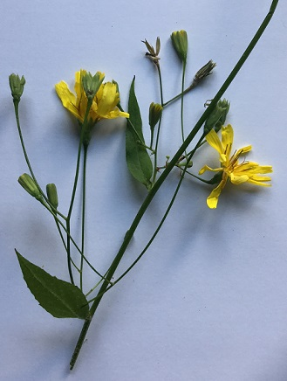

Lapsana communis ssp. intermedia (Photo C Smith)

Legousia hybrida (Venus’s-looking-glass) This is another weed of arable crops which has almost vanished from our countryside with modern farming methods. It was last recorded in 1998 until Mick Lacey discovered it in a field of Broad Beans last year at Clowne (SK508767).

Lysimachia thrysiflora (Tufted Loosestrife) This is a rare native perennial of wet places in marshes and by ditches in northern Britain from central Scotland down as far south as southern Yorkshire. At least it was until Sue Murdoch reported it from the grassy margin of a seasonal pond in Chapel-en-le-Frith (SK054795). I hope to be able to take a Flora Group meeting there this year to see the site and maybe confirm the southern extension of the native range of this plant into Derbyshire.

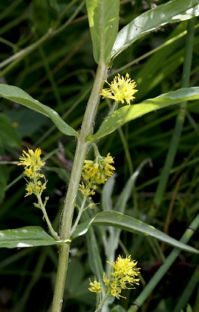

Lysimachia thrysiflora Chapel 2016 (Photo S Murdoch).
Mahonia japonica (Japanese Mahonia) Brian Gough reported this as a new county record from Furnace Road, Little Hallam (SK4740) in August last year. Possibly originally planted, like all newly recorded aliens I consider it as casual until it has survived at least five years.

Nicotiana tabacum (Tobacco) This another of Brian Gough’s first county records was found at the Storage Depot, West Hallam (SK4340) in August of last year.

Nothofagus alpina (Rauli) This was recorded by Brian Gough off Ladywood Road, Ilkeston (SK4640) in August 2016. This is a large deciduous tree that can self-sow from planted individuals. It will be interesting to see if it does so here.

Potentilla indica (Yellow-flowered Strawberry) My attention was attracted last August by some red strawberry-like fruits on the ground under trees on the western verge of the A515 at Clifton (SK168443). On inspection, each had a bite out of them but they were otherwise whole. It would seem the fruits of this introduced plant also fooled members of the local fauna into thinking they were real strawberries.

Rosmarinus officinalis (Rosemary) Ken Balkow reported this new county record and culinary herb growing and flowering high up on a wall at Hardwick Hall (SK462636) in January last year. No doubt the progeny of one of the many plants of this species grown in the herb garden at the hall.

Ruta graveolens (Rue) I found seedlings of this herb growing in a neglected flowerbed at the University of Derby on Kedleston Road (SK3338) in the absence of any parent plants during May last year. However, they did not survive renewed gardening activity in the flowerbeds later in the year.

Samolus valerandi (Brookweed) This is a very rare member of the Primrose family with us. Roy Frost made only our second modern record when he discovered it near Fox Green (SK530735) in September last year.

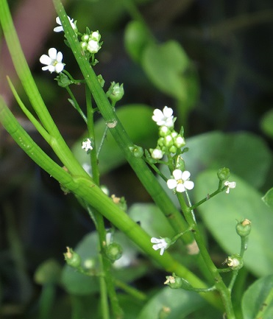

Samolus valerandi Near Fox Green (Photo R Frost).

Sasa palmata (Broad-leaved Bamboo) I found one clump of this growing vigorously with dumped rubbish on the side of a track into Cobnar Wood (SK357756) in August last year. This is the first local record for the introduced garden ornamental.

Scilla sardensis (Lesser Glory-of-the-snow) There have been a number of records of Glory-of-the-snow (S. forbesii) locally but the first record for the Lesser plant was made last year in April by Andy Amphlett at Ashbourne Green (SK188473). There was but one plant growing in grassland.

Scilla siberica (Siberian Squill) This other species of Scilla was reported growing outside a garden in Lathkill Dale (SK203661) in April 2015 by Jon Mortin. This is yet another first county record for a garden ornamental which has escaped or been discarded from a cultivated enclosure.

Spiraea japonica (Japanese Spiraea) This is the last of our escaped garden ornamentals for the year though I suspect there will be more to come in the future. It was noted by Brian Gough in Stanton Road, Ilkeston (SK4660) in July last year as variety “Little Princess”.

3. CONYZA SPECIES
To my shame, I was only vaguely aware until last year that there was more than one species of Conyza in Derbyshire. I now know there are at least four, a couple of which look set to be reasonably common once we can recognise them. The four plants appear to be easy to tell apart if they are in flower. One needs to look at the individual flowerheads. These are made up of tiny individual flowers called florets surrounded by small scales or bracts called phyllaries.

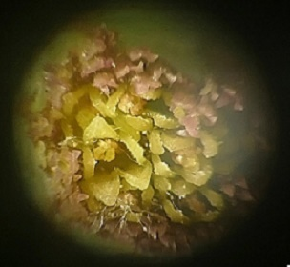

Conyza floribunda Close-up of floret showing 5 lobed corolla tube (Photo. M Lacey).

Two species have hairless phyllaries. These are the widespread Canadian Fleabane (Conyza canadensis) and the much rarer Bilbao Fleabane (C. floribunda). The latter plant was only recorded for the first time in the county last year but is now known from at least 8 sites in the east of the area. They can be told apart by gently squeezing a flowering head from below such that the florets pop up. In the Canadian Fleabane, each floret has four petal lobes, whilst in the Bilbao each has five.

Two species have hairy phyllaries, these are the Guernsey Fleabane (C. sumatrensis) and the Argentine Fleabane (C. bonariensis). These also both have five lobed petal tubes. The Guernsey had three records in our recent Flora but has had ten more last year. The Argentine has been found only once, which was last year in New Street, Alfreton (SK409556). They are separable on the appearance of the flower head. In the Guernsey, the flowerheads tend to be bulbous at the base and pinched in at the top with greenish/yellowish phyllaries. In the Argentine, the flowerheads are fatter and barrelled shaped with reddish tips to the phyllaries (See page 1).

4. PROGRESS WITH PLANT RECORDING LOCALLY
In the past I, have been mostly concerned with reporting on recording for BSBI date class five (2010 – 2019) in hectads completely within Derbyshire and only concerned with the total number of plants per hectad recorded within recent years. The BSBI is now asking me to look more towards recording for the new Atlas where the recent time period is 2000 – 2019 and to consider all hectads that are present in our area not just the complete ones. To help with these changed priorities the BSBI have come up new criteria for assessing progress in recording. I am therefore now explaining only progress with recording for the new Atlas, after a note on the current size of our database.

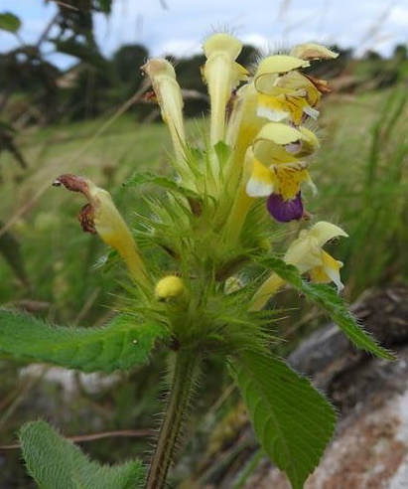

Galeopsis speciosa Bonsall Moor July 2016. A plant to look out for while recording (Photo M Lacey).

Current size of database
Last year we added around another 36,000 records to our local plant database to bring the total since 2011 to over 230,000. These now include around 1,600 different types of plant.

Progress with Atlas 3 recording
The current date category in the new Atlas, which is to be published about 2022, is to be 2000 – 2019 i.e. for a plant to be shown as currently present in a square in the Atlas it must have been recorded in the period. Squares here are hectads (areas 10 x 10 km) as in previous Atlases. To assess progress in completing the work for this new Atlas, the BSBI have come up the concept of a “well recorded” hectad. Once a hectad is deemed to be well recorded they would prefer recorders to look to other hectads in their area which are not be well recorded. I have used this principle in devising the series of outdoor visits this year.

For a hectad to be considered well recorded it must satisfy two criteria, one of which refers to tetrads within the hectad and one of which refers to the total recorded flora of the hectad. The criterion for tetrads states that for a hectad to be considered well recorded five or more tetrads within it must be themselves well recorded. If a hectad is only partly within a vice county i.e. it is a marginal square, the number of required tetrads is reduced in proportion to the area of the hectad remaining within the vice county. For a tetrad to be considered well recorded, there must be more than 100 plants recorded for the square, and more than 75% of these must have been seen in the current recording period. The criterion for the total flora of a hectad states that for a hectad to be well recorded 75% or more of all plants ever recorded in the square must have been recorded since 2000.

These two criteria are brought together on the adjacent map in a traffic light scheme where hectads achieving both criteria for vice county 57 (Derbyshire) are shown in green; where only one criterion is met in yellow; and where neither are met in red. Red squares are thus our first priority and yellow our second. Further recording can be done in green squares but it would be preferable if it were not done at the expense of work in other squares. Our two red squares are very different. SJ99 is a minor marginal square for us. Only one well recorded tetrad is expected and 61% of all plants recorded for the hectad in Derbyshire have been recorded since 2000. SK36 is a hectad completely within Derbyshire so five well recorded tetrads are expected of which three have already been completed. Furthermore 68% of all plants ever recorded in the area have already been noted since 2000 leaving only 7% to be found. The full set of statistics for all 42 hectads which are wholly or partly in vc57 (Derbyshire) are included at the end of this newsletter.

APPEAL FOR RECORDING Please consider helping to finalize the recording for the new atlas by converting our red and yellow squares to green. There are at least two ways to help here. One is to request from me a list of plants recorded in a hectad but not seen recently, and then try and find them. The second is simply to record a card or cards in hectads you have not recorded in before. We all record/recognize different plants and the second approach should pick up species not recorded by other surveyors. I am happy to discuss or help recorders with any other ideas to finalize recording for the Atlas.

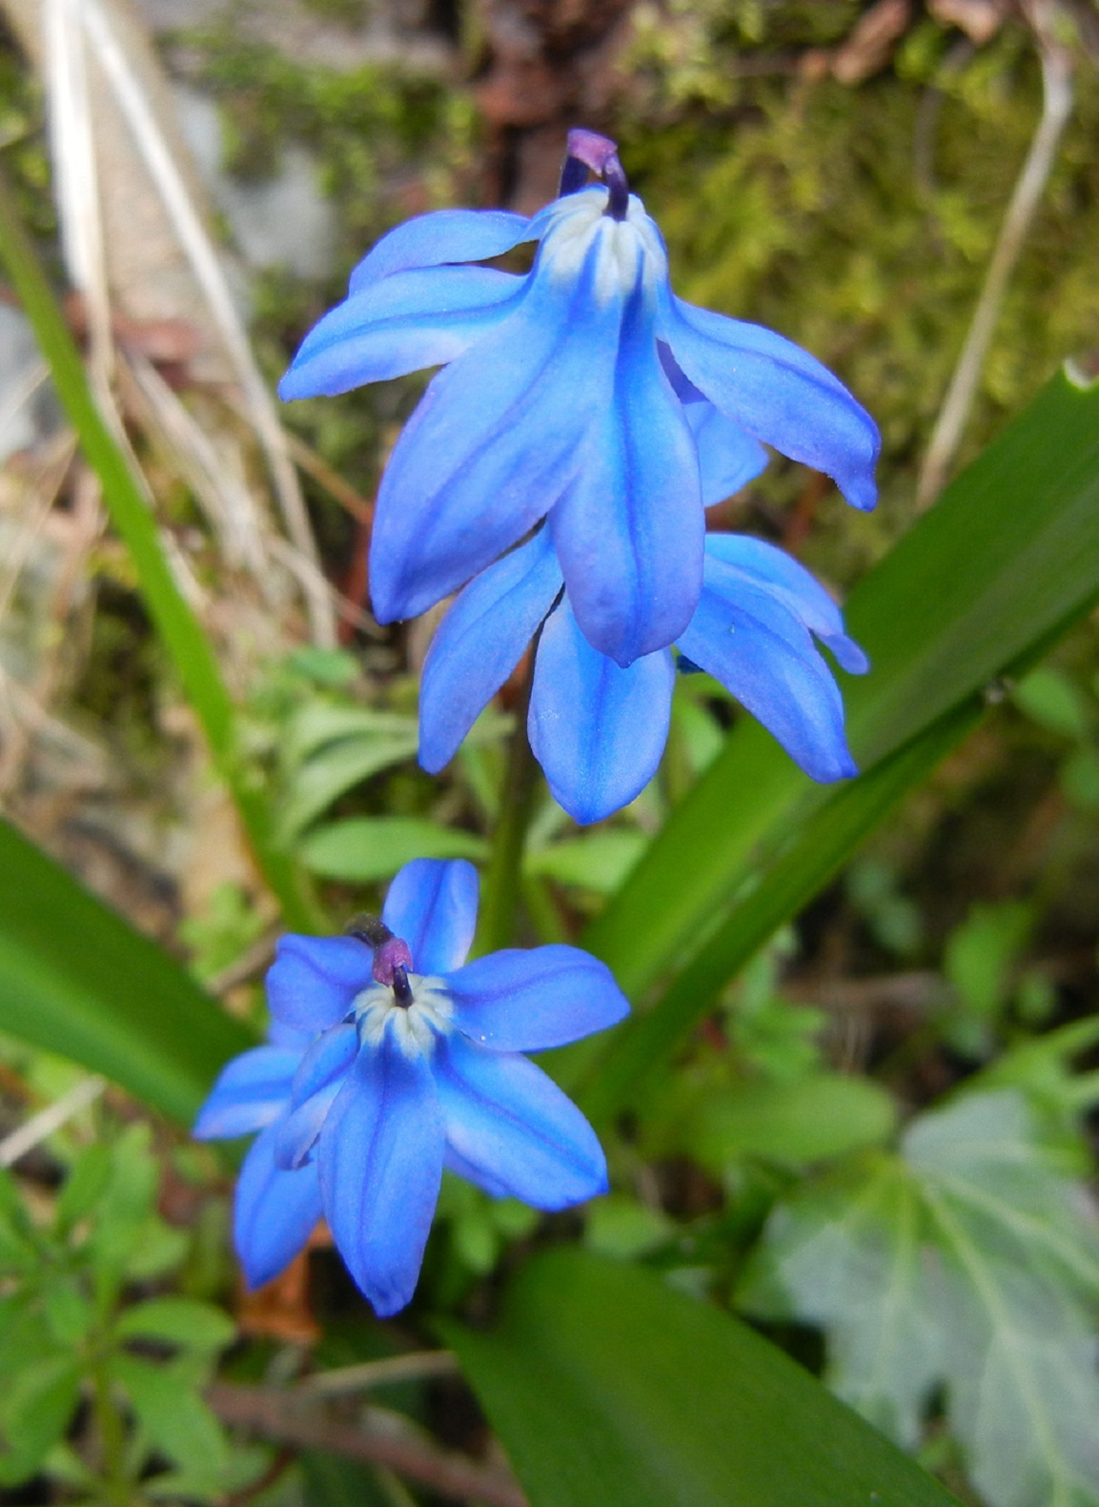

Scilla siberica A new county record Lathkill Dale April 2015 See page 4 Photo. J. Morton.

5. OUTDOOR MEETINGS 2017
I have organised a series of outdoor meetings in Derbyshire on the same basis as previous years that is I have included some suggestions from others, some areas that need recording for the new Atlas and some areas just to see interesting plants. I circulate details with this newsletter, though note that are the same as circulated earlier in my previous e-mail (See page 10).

6. ENQUIRIES
Any enquiries concerning the Flora or the recording of higher plants in Derbyshire can be made to me at my address below. Enquiries about plant identifications should also be sent to me but please always include details of where and when specimens were found. I find photographs generally a better means of identification these days as they can be e-mailed to me and do not rot if specimens arrive when I am away.

Distribution maps and draft species accounts produced some years ago, can still be viewed on the website of Derby City Council at www.derby.gov.uk/flora . Please note however that these are now many years out-of-date for many species. If you require more recent information, you can refer to our Flora of Derbyshire which was published in 2015 by Pisces Publications. Copies of which I still have available for sale at the pre-publication price.

Dr Alan Willmot
2 Kedleston Close Allestree
Derby DE22 2RA
Tel. 01332 550373
Mobile (used on field trips) 0794 121 4977
E-mail alanwillmot@outlook.com

 | SJ99 | SK09 | SK19
 | SJ98 | SK08 | SK18 | SK28 | SK38 | SK48
 |  | SK07 | SK17 | SK27 | SK37 | SK47 | SK57
 |  | SK06 | SK16 | SK26 | SK36 | SK46 | SK56
 |  |  | SK15 | SK25 | SK35 | SK45
 |  |  | SK14 | SK24 | SK34 | SK44
 |  | SK03 | SK13 | SK23 | SK33 | SK43 | SK53
 |  |  | SK12 | SK22 | SK32 | SK42
 |  |  | SK11 | SK21 | SK31
HECTAD STATUS FOR 2020 ATLAS AS AT 19th January 2017
 |  | For further details of hectads see following table.
 |  |  | Hectads without the required number* of well recorded
 |  |  | tetrads and less than 75% of species refound.
 |  |  | Hectads with the required number* of well recorded
 |  |  | tetrads* but less than 75% of species refound.
 |  |  | Hectads with the required number* of well recorded
 |  |  | tetrads* and 75% of species refound.
 |  |  |  | *Five well recorded tetrads are requried for a
 |  |  |  | complete hectad but fewer for a marginal one.

 |  | Table 1: HECTAD STATUS FOR ATLAS 2020 as at 19th Jan 2017
 |  | Hectad |  | No. of Well Recorded tetrads |  |  | % Flora refound | Result
 |  |  |  | Completed | Expected
 |  | SJ98 |  | 1 | 1 |  | 61% | Yellow
 |  | SJ99 |  | 0 | 1 |  | 61% | Red
 |  | SK03 |  | 2 | 0 |  | 96% | Green
 |  | SK06 |  | 2 | 2 |  | 70% | Yellow
 |  | SK07 |  | 11 | 5 |  | 69% | Yellow
 |  | SK08 |  | 9 | 5 |  | 69% | Yellow
 |  | SK09 |  | 11 | 5 |  | 72% | Yellow
 |  | SK11 |  | 1 | 1 |  | 68% | Yellow
 |  | SK12 |  | 0 | 0 |  | 64% | Yellow
 |  | SK13 |  | 16 | 5 |  | 73% | Yellow
 |  | SK14 |  | 7 | 4 |  | 57% | Yellow
 |  | SK15 |  | 9 | 4 |  | 70% | Yellow
 |  | SK16 |  | 15 | 5 |  | 76% | Green
 |  | SK17 |  | 8 | 5 |  | 74% | Yellow
 |  | SK18 |  | 11 | 5 |  | 76% | Green
 |  | SK19 |  | 7 | 4 |  | 77% | Green
 |  | SK21 |  | 7 | 4 |  | 72% | Yellow
 |  | SK22 |  | 8 | 3 |  | 70% | Yellow
 |  | SK23 |  | 7 | 5 |  | 70% | Yellow
 |  | SK24 |  | 18 | 5 |  | 68% | Yellow
 |  | SK25 |  | 14 | 5 |  | 74% | Yellow
 |  | SK26 |  | 5 | 5 |  | 70% | Yellow
 |  | SK27 |  | 21 | 5 |  | 77% | Green
 |  | SK28 |  | 8 | 3 |  | 70% | Yellow
 |  | SK31 |  | 1 | 1 |  | 74% | Yellow
 |  | SK32 |  | 14 | 5 |  | 69% | Yellow
 |  | SK33 |  | 16 | 5 |  | 70% | Yellow
 |  | SK34 |  | 10 | 5 |  | 73% | Yellow
 |  | SK35 |  | 11 | 5 |  | 73% | Yellow
 |  | SK36 |  | 3 | 5 |  | 68% | Red
 |  | SK37 |  | 22 | 5 |  | 75% | Green
 |  | SK38 |  | 12 | 3 |  | 81% | Green
 |  | SK42 |  | 3 | 1 |  | 80% | Green
 |  | SK43 |  | 18 | 5 |  | 81% | Green
 |  | SK44 |  | 16 | 4 |  | 82% | Green
 |  | SK45 |  | 15 | 4 |  | 82% | Green
 |  | SK46 |  | 12 | 5 |  | 81% | Green
 |  | SK47 |  | 17 | 5 |  | 79% | Green
 |  | SK48 |  | 8 | 2 |  | 81% | Green
 |  | SK53 |  | 2 | 1 |  | 87% | Green
 |  | SK56 |  | 2 | 1 |  | 68% | Yellow
 |  | SK57 |  | 11 | 3 |  | 81% | Green
DERBYSHIRE FLORA GROUP |  |  |  |  |  | OUTDOOR MEETINGS 2017
All meetings are held on Saturdays & start at 10.30 am. They usually end by 4.30 pm. Carry lunch.
Date | Month |  | Venue |  |  | Meeting Point & Reason
25th | March |  | Tissington area (SK15) |  |  | Car park at Thorpe at SK163504 for general & woodland flora
22nd | April |  | Carsington area (SK25) |  |  | Car park at Sheepwash (SK249528) for village and woodland at northern end of reservoir
13th | May |  | Millers Dale (SK17) |  |  | Car park at Miller's Dale Station at SK138732 for general limestone grassland flora
3rd | June |  | White Path Moss (SK28) |  |  | Car park at Hook's Lane at SK244829 for general & moorland flora
1st | July |  | Chapel & Combs Reservoir (SK07) |  |  | Car park at Combs Reservoir at SK033797 for Lysimachia thrysiflora at only Derbyshire site & reservoir drawdown flora
22nd | July |  | Stanton-By-Dale (SK43) |  |  | Outside Stanton Gate Local Nature Res. at SK483382 for ruderals & escapees. Leader: Brian Gough.
19th | August |  | High Peak Junction (SK35) |  |  | Car park at High Peak Junction at SK314560 for general & canalside flora
9th | September |  | Longdendale (SK09) |  |  | Tor Side Car park at SK068983 for general & wayside flora
30th | September |  | Bottom Moor (SK36) |  |  | Roadside Wirestone Lane by forest entrances at SK321633 for general & moorland flora
N.B. some of these meetings start from pay & display car parks where change is not usually available.
Meetings organiser: Dr Alan Willmot |  |  |  |  |  | Mobile on day: 0794 121 4977
 | Home: 2 Kedleston Close, Allestree, Derby, DE22 2RA. Tel. 01332 550373.
 | Email: alanwillmot@outlook.com
Anyone interested in botany is welcome to come on these meetings but please contact the organiser
if you have not attended one of the events before.
 |  |  |  |  |  | 17th January 2017
A.Willmot |  |  | Floravc57/Meetings/Meets2017 Final

