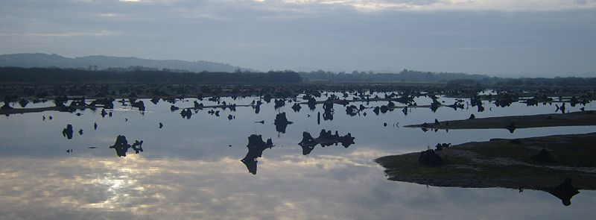
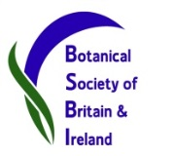
Co Cork 4-day recording event 2016

1st- 4th Sept, based out of Ballyvourney, Co. Cork

Aimed at helping with recording for Atlas 2020, this 4-day event will provide a great opportunity to explore some of the best habitats Co Cork has on offer. The first day will be in East Cork at one of the largest saltmarshes in the country. Here we will learn more about this fascinating habitat with saltmarsh specialist Mark McCorry (VCR H14, Laois), along with Lynda Weekes and Úna FitzPatrick (National Biodiversity Data Centre) who will talk us through any sedges and grasses we see. The other 3 days will be based in the woodlands, mountains & valleys around Macroom and Millstreet, including the famous alluvial woodland of The Gearagh (above).

The week will be a great opportunity to learn, to explore, to catch up, and, very importantly, to produce records for some of the least well recorded areas in West Cork (H3), as well as some of the rest of Co Cork (H4 and H5). Clare Heardman (VCR for H3) and Edwina Cole (caretaker for H4/5) will be the leaders, along with others including Rory Hodd (joint VCR for Kerry) and Maria Long, the BSBI Irish Officer.

This event is designed to appeal to all levels of ability, from seasoned recorders to botanical beginners. Residential recording events like this are a great way to learn from each other and improve your botany. There will be plenty of experts on hand, so you can learn their ID tips in the field and also have the chance to share and learn further in the evenings. And of course have some good craic! Feel free to come for some or all of the week. We will go out in smallish groups and target specific squares. If you’re interested in coming along, book now using the attached form!

‘Base camp’: We will base ourselves in Ballyvourney (Baile Bhuirne), a small village on the N22 between Macroom and Killarney. Recording events like this work best when most people stay over in the same place. This allows plenty of time for socialising, planning, sharing and learning. We have reserved rooms in The Mills Inn, but places are limited so book now to avoid disappointment. The local EPA office have kindly agreed to sponsor some lunches – so big thanks to them!

To book: Please fill out this form and email to clare.heardman@ahg.gov.ie

Accommodation: The Mills Inn, Ballyvourney, Co. Cork Web: http://www.millsinn.ie/
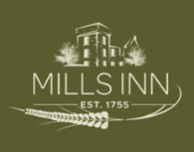
Tel: Treasa at +353 26 45237 Email: info@millsinn.ie
Special package: €65/person/day (Dinner, B&B & packed lunch).
B&B only: €40/person
Note: Please quote ‘Catherine Ketch’ to avail of the special rates.
Alternatively, there are B&Bs in the village or hotels in Macroom & Killarney.

Enquiries: - Clare Heardman, VCR West Cork. Email: clare.heardman@ahg.gov.ie
Tel: +353 87 6781613 or Edwina Cole edwinacole@eircom.net
- Or visit the Irish BSBI webpage: http://www.bsbi.org.uk/ireland.html
- Note that further detailed information will be provided to those who book

Deadline: Please send this form & book accommodation (if staying in ‘base camp’) ASAP but by August 26th at the latest.

Co Cork 4-day recording event 2016 – Attendance Booking Form
(NB: please book your accommodation separately)

Please return this form to clare.heardman@ahg.gov.ie by August 26th

Name
Address
Mobile No.
Email
Attendance | Do you plan to attend:  All days ………………………… Y / N  Thurs 1st Sept (East Cork) ………………………… Y / N  Fri 2nd Sept (West Cork) ………………………… Y / N  Sat 3rd Sept (West Cork) ………………………… Y / N  Sun 4th Sept (West Cork) ………………………… Y / N
Transport | Will you have your own car? ………………………… Y / N  Would you be willing to drive on some recording days? ………………………… Y / N  (NB: no pressure on anyone to drive!)
Experience | To help us plan, can you let us know if you are:  An experienced field botanist ………………………… Y / N  An improver ………………………… Y / N  A beginner ………………………… Y / N

Note: You will need to be reasonably fit, however we will endeavour to offer a variety of squares to survey to suit all (physical) abilities and energy levels each day!

