Mersehead 7th August 2021

We started the meeting in rain and I was almost prepared to call it a day, but fortunately it ceased about 15 minutes in, by which time we’d almost walked out to the western-most merse compartments.

Our first stop was in what is termed middle marsh communities with common species like sheeps fescue Festuca ovina and saltmarsh rush Juncus gerardii with a scattering of sedges (“sedges have edges”). These included false fox sedge Carex otrubae with the florescence in a dense clump at the top of the flower stalk and a short bract at its base; then C. extensa long-bracted sedge, much as its name sounds;

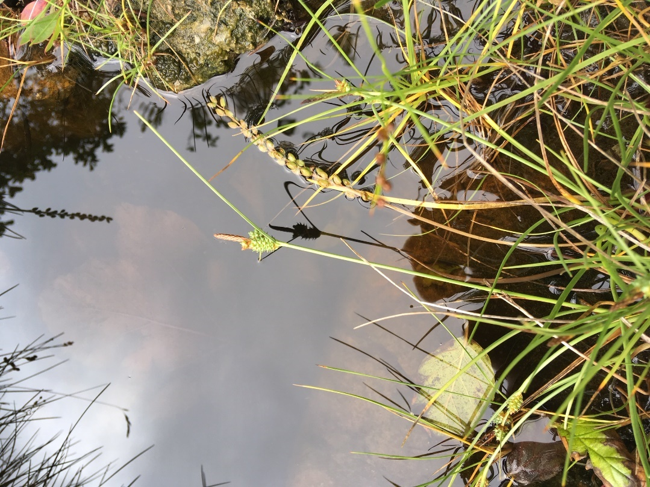

and C. distans distant sedge (I mistakenly called it C. hostiana Tawny sedge) with one of its inflorescence near the base of the stem. We spent so\me time with rushes (“rushes are round”, referring to the stem) – Juncus effusus soft rush with a rounded smooth stem supporting either a compact dense head or a spreading loose cluster; compact rush Juncus conglomeratus with a very dense head and tiny ridges to the stem, only obvious when rolled between the fingers; then clumps of yet another rush, sea rush J. maritimus with stiff springy stems and a long bract extending way beyond the fruiting heads.

The ground levels varied slightly but sufficiently to influence the species composition. A drop of a few cms. and we encountered masses of the smaller, more delicate saltmarsh rush J. gerardii. Here too we had the dark green shoots of Glaux maritima sea milkwort which in spring is a mass of pink flowers and scattered plants of Plantago maritima sea plantain and Triglochin maritima sea arrowgrass (also in the above photo). These last two were distinguishable by the first species having a dense flower spike (no space between each flower) and the second sp. by a much wider spacing of the flowers/seeds on the flowering stem and the very flattened base of the stem and leaves at ground level. I pointed out a prostrate grass which was creeping along the mud of a saltpan (a further drop in ground level of a few cm), one with purplish stems, and should have called it Puccinellia maritima common saltmarsh grass, but somehow managed to label it creeping bent! Apologies…but it was present along the path back to the cars.

A drop of a few more cm in ground level and we came to the low saltmarsh community with Salicornia glasswort (or samphire as its sold for salads,etc), a very succulent salty-tasting plant with fleshy, bright green cylindrical leaves. Most of us tried it for the taste! Nearby also in the saltpans was Spergularia marina lesser sea-spurrey, straggly stems – another pink flower earlier in the year; and annual seablite Suaeda maritima. At this level we also came across Atriplex portulacoides sea purslane, a greyish leaved plant which has been spreading along the north Solway coast recently and the county’s uncommon Atriplex littoralis grass-leaved orache – which turned out to be more widespread and scattered over the merse here. In the distance a dark purple band turned out to be masses of Limonium sp. sea lavender in flower where we spent some considerable time trying to sort out L. vulgare common sea lavender from L. humile lax-flowered sea lavender. Best bet was to count the florets on each side branch – more than 8 the common one, 6 or less the lax-flowered one.

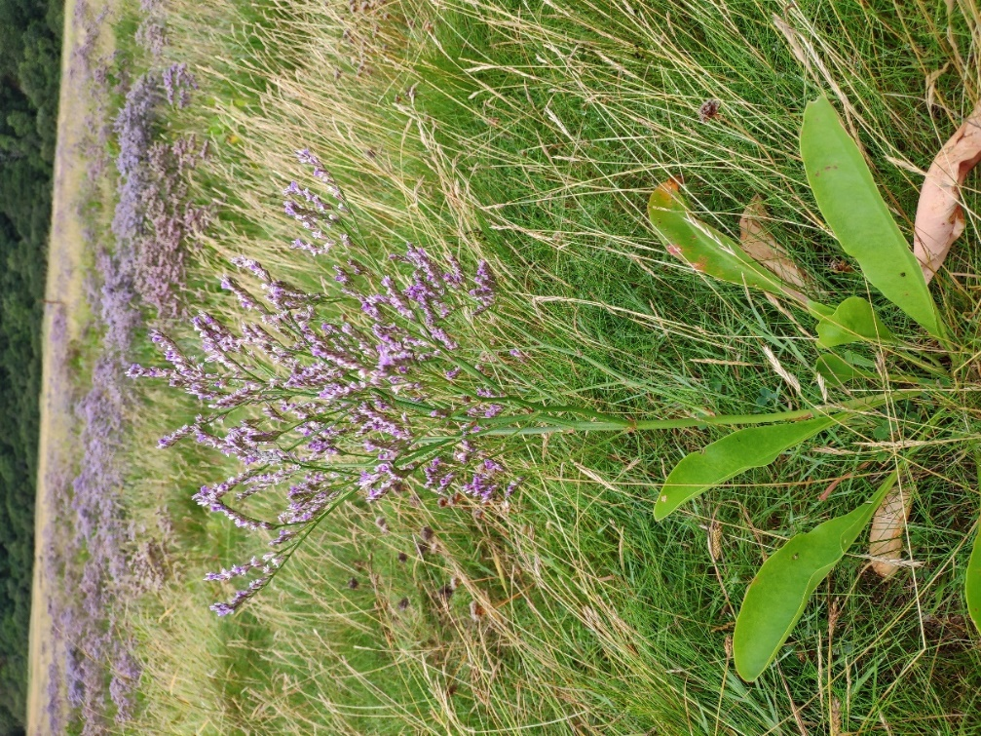
Common sea lavender

Lunch after this and a short walk to the low dunes. Here was a very different suite of plants, some scarce both at national and vice-county level. David rapidly found haresfoot clover Trifolium arvense in several patches

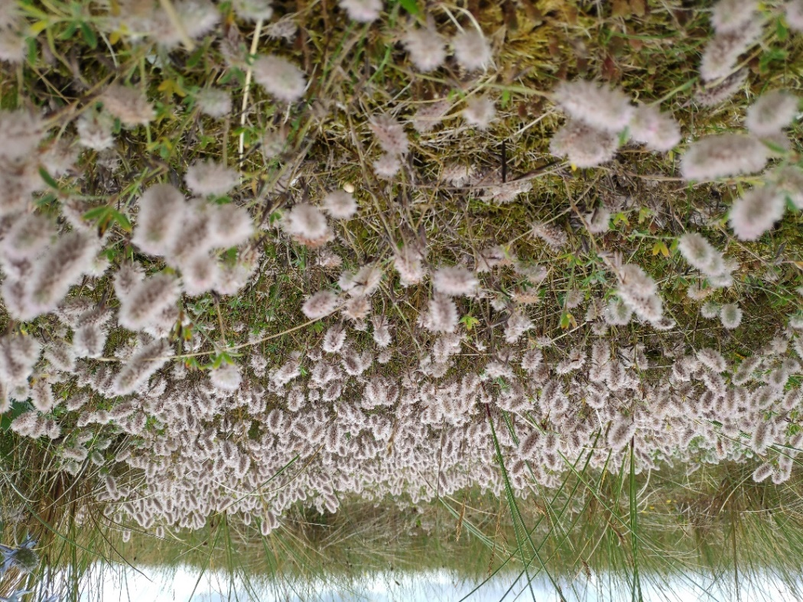

followed by sea holly Eryngium maritimum,

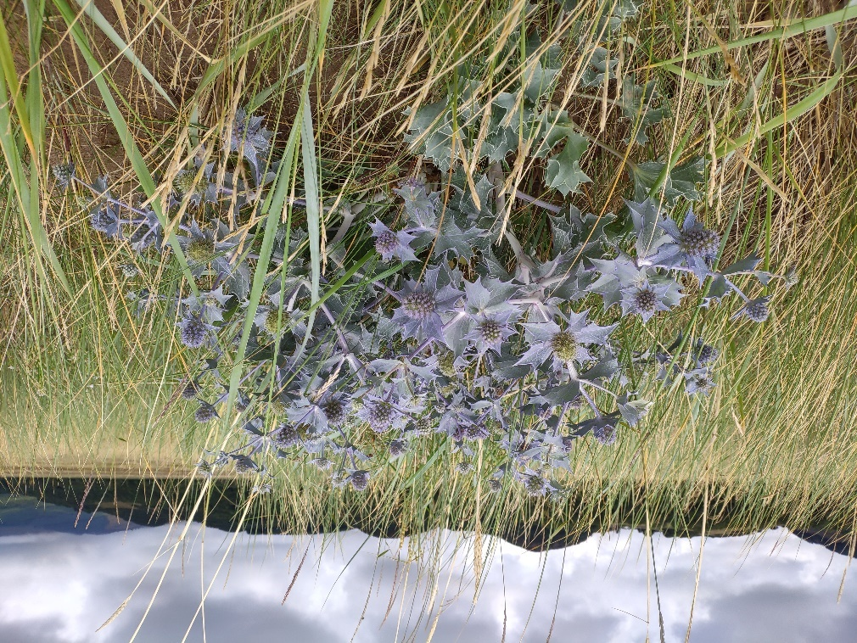

sea spurge Euphorbia paralias, sea rocket Cakile maritima of pale pink flowers, prickly saltwaort Salsola kali and the Solway speciality Isle of Man cabbage Coinzya monensis subsp. monensis, in size a very small 4-petalled yellow flowered plant with salad rocket-like leaves.

I could go on with more names and more photos, but suffice it to say that we found 104 species in all just in this one monad (1 x 1 Km square). Although I strongly suspect that several species were missed – there’s only so much time and concentration needed for such a rich and varied site. All photos except for the sedge were courtesy of David Foreman to whom thanks for such excellent photography. Hope you all enjoyed the meeting.

