Almorness Peninsula 13th August 2021

What a day this turned out to be! Rather a long walk in from the car park for the nine of us, but well worth it. The first monad (NX8253) was mainly confined to the forest track and the adjoining woodland, only giving us 2 sedges (Carex echinata star sedge and C. sylvatica wood sedge) and four rushes. Two hemp nettles Galeopsis spp. were alongside the track, G. tetrahit common hemp nettle with its flat lower lip and G. bifida lesser hemp nettle with a notched lower lip the edges of which curved under slightly. Also there was just a single plant of Hypericum humifusum Trailing St John’s wort, aptly named for its habit, and with rather large, in relation to the rest of the plant, yellow flowers. The woodland contained three Ancient Woodland Indicator species, Mercurialis perennis dog’s mercury, Circaea lutetiana common enchanters nightshade and Chrysosplenium oppositifolium opposite-leaved golden saxifrage. The semi-parasitic plant Odontites verna red bartsia with its red flowers in a spaced spike was scattered along the edge of the track, while on a wetter side track some of us tasted the peppery leaves of the aptly named Persicaria hydropiper water pepper, with its somewhat lingering taste. The accompanying Persicaria maculosa redshank was also there, recognisable by the large dark spot on each leaf – sometimes it’s pale grey, sometimes very black, but always variable in size. This area also turned up several flowering plants of Spergula arvensis corn spurrey, a species listed a Threatened in the UK, but pretty common throughout the lowlands of VC73. It’s basically a species of open disturbed ground, such as arable fields but is now more frequently found on roadside verges, well-worn tracks, field gates, etc. Two of the three species of Sonchus sow thistle turned up – the extremely prickly-leaved S. asper prickly sow thistle and the less spiny, but still prickly S. arvensis perennial sow thistle. Torilis japonica hedge parsley, rather like a very delicate and much more open cow parsley, was now in full flower (July-September), later than the cow parsley (April- June usually), along the track edges. In all 125 species, nothing outstanding, in this monad but a nice variety of the commoner species.
I’ve just picked up that amongst the many specimens I brought home, there was a shoot of the hybrid Stachys x ambigua hybrid woundwort, recognisable by the shortly stalked (characteristic of S. sylvatica) and linear (characteristic of S. palustris) upper leaves. Not many records of this in the VC, only 7 since 2000 compared to about 40 pre-2000. Probably due to under-recording, not a decline.
The second monad (NX8352) was much more interesting, partly because of the more varied habitats – sand, mud, rocky patches, marsh and merse, woodland and scrub, dune grassland, scrub grassland and flushes. The ground varied from calcareous sandy/shelly ground, through neutral areas to some acidic bits, as well as sea-water influenced areas. Lunch on the dune grassland at Horse Isles Bay amid sunshine while we noted the straight lines of dark green shoots of Carex arenaria sand sedge, the bright green clumps of Spartina anglica common cord grass in the mud of the bay, and the pink pea-like flowers of the short but tough Ononis repens restharrow. And Agrimonia eupatoria agrimony of the long spike of yellow flowers and inwardly hooked spines of the fruits arising from a rosette of leaves was scattered through the dune grassland and beyond, obviously grazed (by rabbits?). At the edge of this grassland where it bordered onto scrub grassland there were stands of Cruciata laevipes crosswort, yellow-green shoots and leaves, with 4 leaves per node in a cruciform shape and flowers in the axils of each node. This is a species almost restricted to the eastern half of the VC.
After that, a great list of records of species previously unrecorded there – Carex diandra lesser tussock sedge; C. lepidocarpa long-stalked yellow sedge with its reflexed bract exceeding the length of the flowering heads; Sagina nodosa knotted pearlwort at the top of the tiny bit of saltmarsh nearby and just below the rocky outcrop;
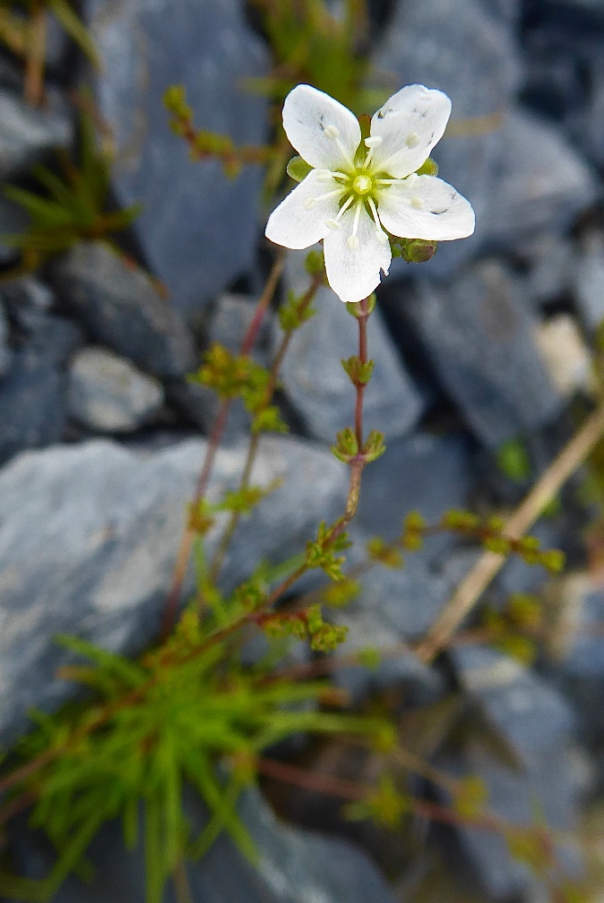
Courtesy of Alan Wake
Samolus valerandi brookweed of the white flowers on a leafy flower stalk, in damp freshwater-flushed areas; nearby a solitary clump of Asplenium adiantum-nigrum Black spleenwort with the black-purple base to the frnd stalk; Centaurium littorale seaside centaury, discovered by Zoe; Eleocharis uniglumis slender spike-rush; and the prostrate, purplish-foliaged Polygonum oxyspermum subsp raii Ray’s knotgrass (a VC rarity) and probably several others. The large flooded/tidal saltpan close to the eastern end of the bay held masses of Bolboschoenus maritimum sea club-rush with Phragmites australis common reed along the edge of the adjoining creek. Beyond that, an area which we didn’t fully explore, were rushes which puzzled me till I got home and examined two flowering/fruiting shoots – closely repeated transverse septa along the leaves, a Juncus articulatus characteristic, but spreading fruiting heads similar to J. acutiflorus, but with differing perianths and capsules - which proved to be the hybrid between the two species J. x surrejanus. Suaeda maritima seablite, Salicornia sp. glasswort, Puccinellia maritima common saltmarsh grass, a single plant of Cakile maritima sea rocket, scattered Limonium vulgare common sea-lavender and a host of other more common seashore plants turned up around there.
On our walk back from the beach, Hypericum elodes marsh St John’s wort was present in a ditch in the woodland. There we also found clumps of Carex remota remote sedge and Isolepis setacea bristleclub-rush with tiny stems and heads of just 2 or 3 fruits overtopped by a short, angled bristle. Both species were yellow-green tufts of fine delicate leaves.
So, 10 sedges and 7 rushes compared to the other monad, and at least145 species in total - and we didn’t cover more than 1/3rd of that monad.
Hope you enjoyed it as much as I did and weren’t too tired after what seemed the long walk back to the cars. Thanks to everyone for spotting things I missed and in particular to Val for valiant efforts to keep records for us.
PS David sent a superb photo of a shield bug at or near White Port, a bit we didn’t all get to:-
“Val found a shieldbug and may be interested to know that I think it was Pentatoma rufipes which appears to favour oak and alder.”
