Under Embargo Until 00:01 BST Wednesday 30 September 2020
Failure to tap into the myriad uses of plants and fungi is costing people and planet, says new report
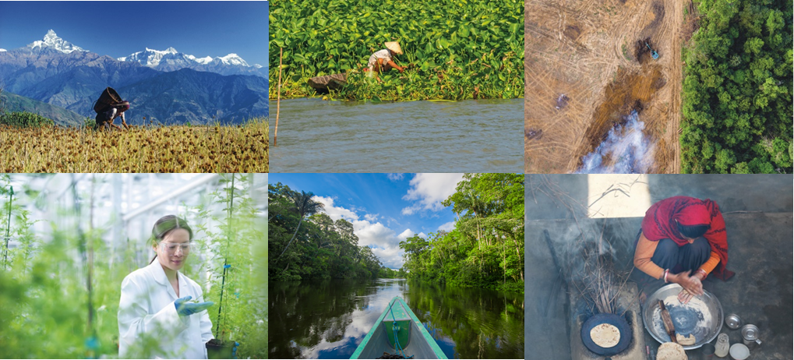
Kew’s State of the World’s Plants and Fungi 2020 report released
VIRTUAL PRESS LAUNCH – Tuesday 29 September at 10am
To download the embargoed report: https://we.tl/t-BG4whbwa04
- Medicine – 723 of the plants we use for medicine at risk of extinction
      - Food & fuel – new data shows we use a tiny fraction of existing species
- 2 in 5 plants threatened – extinction risk may be worse than previously thought
- 4000 newly named species – potential new foods, medicines & timber found in 2019
- Race against time – pace of finding, naming and conserving species is too slow
- In-depth look at biodiversity in the UK and its overseas territories – significant knowledge gaps need addressing
- Data from 12 scientific papers published today underpin the report
- 3-day online symposium on the report findings to follow on 13-15 October

RBG Kew’s fourth State of the World’s report, released today, takes a deep dive into the state of the world’s plant and fungal kingdoms globally. The new data, the result of a huge and unprecedented international collaboration bringing together 210 scientists from 42 countries, show how we are currently using plants and fungi, what useful properties we are missing, and what we risk losing.
Plants and fungi are the building blocks of life on planet Earth. They have the potential to solve urgent problems that threaten human life, but these vital resources are being compromised by biodiversity loss. The report highlights the pressing need to explore the solutions that plants and fungi could provide, to address some of the pressures facing people and planet.
This landmark report is the first time plants and fungi have been combined in one global State of the World’s assessment, with the underlying data also published today in a series of scientific research papers made freely available in the leading journal Plants, People, Planet.
Professor Alexandre Antonelli, Director of Science at RBG Kew, says:
“The data emerging from this year’s report paint a picture of a world that has turned its back on the potential of plants and fungi to address fundamental global issues such as food security and climate change. Societies have been too dependent on too few species for too long. At a time of rapid biodiversity loss, we are failing to access the treasure chest of incredible diversity on offer and missing a huge opportunity for our generation. As we start the most critical decade our planet has ever faced, we hope this report will give the public, businesses and policymakers the facts they need to demand nature-based solutions that can address the triple threats of climate change, biodiversity loss and food security.”

2 in 5 plants are now estimated to be threatened
Kew’s 2016 State of the World’s Plants report estimated 1 in 5 plants were at risk but new analyses this year show that extinction risk may be much higher than previously thought, with 39.4% plants estimated to be threatened with extinction. This jump in proportion/percentage is due to more sophisticated conservation assessments and new analytical approaches to correct biases in current data. Accounting for under and over-represented plant groups and geographical areas enabled the scientists to estimate extinction risk more accurately. The new approach used by scientists this year predicted the overall proportion of threatened species to be 39.4%, almost double the 21% of global plant species estimated to be threatened with extinction in 2016.
Authors suggest the best course of action now is to ‘fast track’ risk assessments so key areas can be protected, and species can be conserved without delay. To achieve this, AI (artificial intelligence) could help to identify priorities for conservation assessments. This new technology can detect if an area contains multiple species that haven’t been assessed, but are more likely to be threatened, which will help speed up assessments for areas in most urgent need.
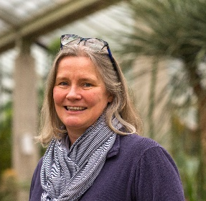
Dr Eimear Nic Lughadha, Conservation Scientist at RBG Kew and lead author of the extinction chapter, says: “We need to have a rough idea of the conservation status of every species – and we now have ways to achieve that with AI approaches that are up to 90% accurate. The techniques are good enough to say, ‘this area has a lot of species that haven’t been assessed but are almost certainly threatened’. And knowing that will enable us to identify the most important areas to conserve in the immediate future.”

723 plants we use for medicine are at risk of extinction
The global demand for naturally derived medicines is threatening some species. New data in this year’s report show that of the 5,411 medicinal plants that have been assessed for their conservation status (out of 25,791 documented medicinal plants), 723 (13%) are categorised as threatened. For fungi, only six medicinal species have been assessed, one of which, eburiko (Fomitopsis officinalis), a wood-inhabiting parasitic fungus with antimicrobial properties, has already been pushed to the brink of extinction.
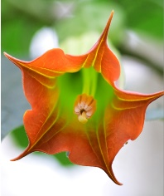
Among these threatened species is Brugmansia sanguinea, a medicinal plant used traditionally for circulatory disorders, which has been listed as ‘extinct in the wild’ by the International Union for Conservation of Nature (IUCN). Other medicinal species at risk of extinction include Nepenthes khasiana, traditionally applied for skin diseases, and the black pepper bark tree (Warburgia salutaris), a traditional medicine for coughs and colds.
It is believed that a rise in the demand for herbal medicines is driven by numerous factors including an increase in prevalence of certain chronic diseases, and the search for new therapies. Worldwide, as many as 4 billion people rely on herbal medicines as their primary source of healthcare, and in China, herbal medicine accounts for about 40% of healthcare services.

South Africa is among the world’s top consumers of medicinal plants, with some 27 million people relying on traditional healthcare. Overharvesting and the unsustainable use of wild medicinal plants is a major concern there; experts believe that a drop observed in the number of species traded between 1998 (700) and 2013 (350) may be due to a reduction in available plant diversity. The collection of bulbs, bark and roots for sale is particularly destructive, as the plant dies after harvesting in around 86% of cases.
Dr Melanie-Jayne Howes, a Chartered Chemist at RBG Kew and lead author of the medicine chapter, says: “Scientific advances are providing opportunities for more sustainable ways to reveal new medicines from nature, to harmonise the therapeutic use of biodiversity with its proactive conservation through nature-based solutions. These strategies provide hope to safeguard supplies of valuable medicines in the future, while demonstrating the value of plants and fungi as an additional incentive for conserving biodiversity.”

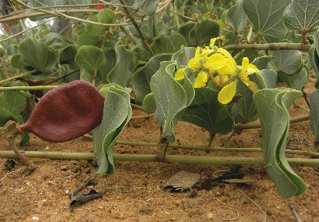
7,039 edible plants that hold potential for future crops
We are overly dependent on a tiny fraction of plants and fungi for our food and energy, despite the thousands of species out there that have the potential to feed and fuel millions around the world.
New data in this year’s report show there are 7,039 edible plants which hold potential as future foods, yet just 15 plants provide 90% of humanity’s food energy intake, and four billion people rely entirely on three crops – rice, maize and wheat. Relying on a handful of crops to feed the global population has contributed to malnutrition and left us vulnerable to climate change. With the global population anticipated to increase from 7.8 billion to 10 billion by 2050, Kew scientists and collaborators researched which overlooked and underutilised plants could hold the key to future-proofing our food production systems. They identified 7,039 plants listed as ‘human food’ from a Kew dataset of useful plants, of which only 417 (5.9%) are considered as major food crops.
Criteria for the 7k food plants were strict – they had to be: nutritious, to deal with millions of malnourished people across the world, robust enough for a changing climate, at low risk of extinction, and have a history of being used as foods, at least on a local level. Foods of the future larder included: the morama bean, a drought-tolerant South African legume, with seeds that when roasted taste similar to a cashew nut and can be boiled or ground to a powder to make porridge or cocoa-like drink; and a drought-tolerant species of pandan that grows in coastal lowlands from Hawaii to the Philippines and produces a fruit that be can be eaten raw or cooked.
Dr Stefano Padulosi, former Senior Scientist at the Alliance of Biodiversity International and the International Center for Tropical Agriculture, and co-author of the food chapter says: “The thousands of underutilised and neglected plant species are the lifeline to millions of people on Earth tormented by unprecedented climate change, pervasive food and nutrition insecurity, and economic disempowerment. Harnessing this basket of untapped resources for making food and production systems more diverse and resilient to change, should be our moral duty to current and future generations.”
2,500 plants that could provide clean energy for millions worldwide
Meanwhile, for the purpose of producing energy, there are 2,500 identified plants that could be used for fuel or bioenergy, but only six crops – maize, sugarcane, soybean, palm oil, rapeseed and wheat – generate 80% of global industrial biofuel. With 840 million people (mainly in sub-Saharan Africa, Asia and Oceania) having no access to electricity and three billion without access to non-polluting cooking fuels and technology, new bioenergy crops are urgently needed.
Until now, research has focused on a few crop species grown for industrial energy supply chains. In an attempt to address this knowledge gap, Kew and its collaborators carried out an in-depth evaluation of the plants and fungi that could be used as a source of energy, assessing the species with the potential to be scaled-up with innovative technologies.

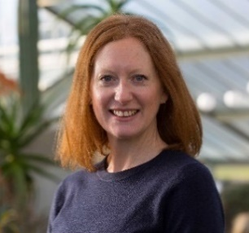
As renewable sources of bioenergy, plants and fungi have a huge contribution to make to reducing both carbon emissions and energy poverty. Fungi, in particular, have much unexplored potential within the bioenergy sector and are abundant and renewable as a resource. However, rather than helping to reduce greenhouse gases and alleviate energy poverty, some of the methods currently used to produce bioenergy are harming the environment and people. For example, in 2019, a ban on sugarcane cultivation in the Amazon was lifted, which could amplify rates of deforestation, releasing carbon dioxide into the atmosphere and threatening species.
The team found various bioenergy initiatives that could be implemented at a local level as a solution to energy poverty. One such example is a microenterprise, EcoFuels Kenya, who source more than 3k tonnes of wild-collected nuts each year. They process the nuts to extract oil to replace diesel in generator engines, while the husks are converted to livestock feed and fertiliser. The authors suggest a combined effort is required to successfully scale up this kind of innovation to provide clean energy for all: researchers and funding bodies need to increase efforts to find local biofuel species in low-income countries; governments need to encourage diversity of agriculture alongside biodiversity conservation; and industry needs to invest in technologies developed for local species.
Dr Olwen Grace, botanist at RBG Kew and lead author of the energy chapter says: “I think that energy poverty can be addressed sustainably within a decade if there is political will, given that we have a diverse pool of plants and fungi to explore and a vast array of suitable emerging technologies. There is real potential to harness the advances in engineering to support diverse, sustainable and resilient landscapes supporting the most essential human needs – food, water and energy.”

Dr Mary Suzan Abbo, Managing Director of Centre for Research in Energy and Energy Conservation, Makerere University, Uganda says: “Every year, as a result of unsustainable wood and charcoal burning in Uganda, thousands of hectares of forest are lost, and thousands of people suffer from smoke inhalation. International collaboration can help us to identify the plants and fungi that will make clean, sustainable energy accessible to everyone. Biofuel technologies have the potential to support both biodiversity and human life.”

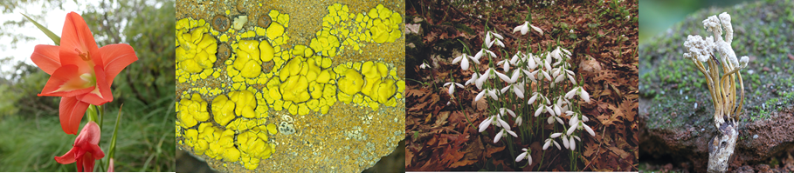
The foods, medicines and timber new to science in 2019
This years’ report is the first time a synthesis of new species to science has been compiled for both plants and fungi. The authors found that 1,942 plants and 1,886 fungi were named as new to science in 2019. Among these exciting discoveries are species that might be valuable as foods, drinks, medicines or fibres. Highlights include:
Foods & drinks:
- Six new species of Allium, the genus to which garlic, onions, leeks and chives belong, were encountered for the first time by scientists in Turkey, Albania, Greece and China
- 10 undescribed relatives of spinach from the genus Chenopodium came to light in California
- 30 previously unnamed species of Camellia, the genus to which tea belongs, were found in China and mainland South-East Asia
- Brazil yielded two wild relatives of cassava (Manihot esculenta), the root vegetable that is an essential ingredient in many Latin American and Caribbean cuisines
- Eight new species of fungi were named from the genus of the edible ‘old man in the woods’ mushroom

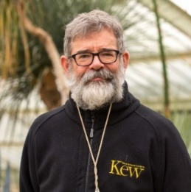
Dr Martin Cheek, botanist at RBG Kew and lead author of the new species chapter says: “These new species have the potential to be really important for future-proofing the cassava crop, which is a staple food for some 800 million people worldwide. The genes present in the wild relatives might be useful in helping to make the current crop pest- or disease-resistant, or to enable it to grow in other habitats with different rainfall or soil fertility patterns.”

Timber:
- A new tree in the mahogany family came to light, and is a possible new source of timber
- Eight new species from the palm genus that supplies rattan to the furniture trade were also named
Medicine:
- Eryngium arenosum, encountered by scientists in Texas, USA, comes from a genus containing plants used to treat inflammation, high blood sugar and scorpion stings
- Artemisia baxoiensis, located in Tibet, is closely related to the antimalarial species Artemisia annua
- Three new species from the genus Oenothera (also known as evening primrose) were newly named – other plants in this genus produce gamma linoleic acids used to treat sclerosis, eczema, and psoriasis
Other headlines in this year’s report include:

- Need to accelerate the pace of species ID – It is a race against time to find, identify, name and conserve species before they go extinct. We cannot protect a species if we do not know it exists – this makes finding, describing, and naming species a critical task. Report authors are calling for more research and funding across the world to urgently address lag between taxonomy and conservation.

- City tree-planting strategies found lacking – The city trees we plant now need to be able to withstand global change over centuries, but current low diversity is leaving them vulnerable to drought, pests and diseases. Trees are the unsung heroes of our cities: they capture pollutants to clean the air, soften rainfall’s impact on soils, reduce flooding, and help mitigate climate change by trapping carbon. But, to ensure we gain the greatest benefit from the ecosystem services that trees provide, we need to plan future cityscapes wisely. Data from OpenTrees.org show that globally, only a small number of species and genera dominate city treescapes – the 10 most common species of nearly seven million trees in 67 locations accounted for 39.5% of trees, of which eight genera make up almost 80%. Not only is diversity of genera and species limited, so is the genetic diversity within species, because species grown in nurseries for planting are often clones. To meet demand for robust trees requires changes to planting strategies. Currently, city authorities are motivated by number targets to reduce greenhouse gases, but if trees are to survive pests, diseases & climate shifts, we need to aim for quality as well as quantity. Report authors suggest that a starting point for selecting species for city planting schemes is to assess the ecosystem services required and to choose diverse species to deliver those services and ensure trees are genetically diverse, which could mean planting rare and untraditional tree species.

- Beekeeping in cities is unsustainable – Current levels of beekeeping in cities are threatening other biodiversity, mainly wild bees, rather than saving it, new data in this year’s report found. Increasing evidence shows that there is insufficient nectar and pollen available to support current beehive numbers in London. This is a problem for bee conservation, as honeybees are outcompeting wild bee populations for food and can also transmit diseases to them. So beekeeping to save bees could actually be having the opposite effect.
Professor Phil Stevenson, scientist at RBG Kew and lead author of the ecosystem services chapter says: “This revelation will surprise many who think that keeping bees is a great thing for the environment. Unfortunately, it isn’t always the case. The public need to be much more aware of the importance of pollinator diversity and how organisms interact, so that we can conserve all urban wildlife more effectively.”

- Only 6.2% of plants and 0.4–5.4% of fungi are associated with patents – Commercialisation of products derived from plants and fungi via patents has the potential to generate wealth, reduce poverty, improve human well-being and raise awareness of biodiversity to incentivise its conservation. However, new data in this year’s report show that a very small percentage of species are associated with patents. An improved patenting infrastructure is needed, including more research into each country’s own natural resources, and strong benefit-sharing agreements put in place globally to increase the development of nature-based products.
Professor Monique Simmonds, Deputy Director of Science at RBG Kew and lead author of the commercialisation chapter says: “Patents increase the economic value of biodiversity. With patents, more people would realise the potential of plants and fungi, because many of those patents would have resulted in some form of commercialisation. And, provided appropriate systems were in place, that would result in money going back to the place where the biodiversity came from.”

UK focus

This year’s report has a chapter focused on the UK, looking at the knowledge gaps of the biodiversity in the UK and the UK Overseas Territories. New data show that despite the UK flora being one of the most studied in the world, there is no single agreed list of the UK’s flowering plants. Current data from the Botanical Society of Britain and Ireland show there are 9,001 species of vascular plants, of which 3,025 are native, but this list differs from others. For fungi, there is even more uncertainty, with estimates for numbers in the UK ranging from 12,000–20,000. There are at least 50 new additions each year, and no comprehensive checklist of British fungi exists. With climate change and habitat loss threatening plants and fungi in the UK, authors suggest these knowledge gaps pose a challenge for conservation in the UK, as you cannot protect what you don’t know about.
In the UK Overseas Territories (UKOTs), the 14 former British colonies that have elected to remain under British sovereignty, even less is known about plants and fungi, despite the fact that the UKOTs remain the jewel in the crown of British biodiversity in terms of unique species and habitats. From new research for this year’s report, Kew scientists and collaborators estimate the current known flora of the UKOTs to be 4,093 species with the number of native species unknown. Only 515 native species have been assessed for their conservation status, with 135 classified as threatened. Again, fungi represent a major knowledge gap, and on the UKOT island of St Helena, more than half the fungi species are categorised as rare and 5 are thought to be extinct.

Dr Colin Clubbe, Head of Conservation Science at RBG Kew and lead author of the UK & UKOTs chapter says: “Unless species are included on the global Red List, people can’t point them out to politicians to say, ‘this is a globally important species.’ If there is a new development being planned in a certain area, it is invaluable to be able to say ‘in this area, we have six globally threatened species, representing 50% or more of their global populations’. This provides the evidence for our partners to push for conservation action. It is vital that we act now to address these knowledge gaps in the UK and UKOTs to prevent species from going extinct and secure the future of these vital natural assets.”
ENDS

- To download a copy of the State of the World’s Plants and Fungi Report, please click here.
- The report will be publicly available from 00:01 BST 30 September here.
- To find out more, request an interview or to access images & B-roll footage of Kew please contact:
Heather McLeod, Senior Press Officer, the Royal Botanic Gardens, Kew on pr@kew.org / h.mcleod@kew.org / 020 8332 3703 / 07464 938860
State of the World’s Plants and Fungi Virtual Symposium: 13–15 October 2020
In conjunction with the publication of the report, Kew will host the first ever State of the World’s symposium focusing on both plants and fungi. Join international scientists, industry representatives and policymakers on 13–15 October 2020 to discuss actions for protecting and sustainably using the world’s plant and fungal biodiversity for the benefit of people and planet. The symposium will take place online, allowing global participation from among a diverse range of skills, experience and ethnic backgrounds. The programme is based around six themed sessions in which invited experts will address a topical question through presentations and a Q&A panel discussion. For more information and to register to attend, please click here.

Notes to Editors
About the Royal Botanic Gardens, Kew
The Royal Botanic Gardens, Kew is a world-famous scientific organisation, internationally respected for its outstanding collections as well as its scientific expertise in plant and fungal diversity, conservation and sustainable development in the UK and around the world. Kew Gardens is a major international and a top London visitor attraction. Kew Gardens’ 132 hectares of landscaped gardens, and Wakehurst, Kew’s Wild Botanic Garden, attract over 2.5 million visits every year. Kew Gardens was made a UNESCO World Heritage Site in July 2003 and celebrated its 260th anniversary in 2019. Wakehurst is home to Kew's Millennium Seed Bank, the largest wild plant seed bank in the world. The Kew Madagascar Conservation Centre is Kew’s third research centre and only overseas office. RBG Kew receives approximately one third of its funding from Government through the Department for the Environment, Food and Rural Affairs (Defra) and research councils. Further funding needed to support RBG Kew’s vital work comes from donors, membership and commercial activity including ticket sales.
About Kew’s State of the World’s reports
- 2016: First ever State of the World’s Plants – Regional focus Brazil
- 2017: State of the World’s Plants – Regional focus Madagascar
- 2018: First State of the World’s Fungi – Regional focus China
- Kew did not release a State of the World’s report in 2019
The State of the World’s Plants and Fungi project has been made possible thanks to a significant donation from the Sfumato Foundation, which was supplemented by existing core staff costs.
About Plants, People, Planet
Plants, People, Planet is a multi-disciplinary Open Access journal, owned by the New Phytologist Foundation and published by Wiley. The journal promotes outstanding plant-based research in its broadest sense and celebrates everything new, innovative and exciting in plant-focused research that is relevant to society and people’s daily lives.

Ekor, M. (2013). The growing use of herbal medicines: Issues relating to adverse reactions and challenges in monitoring safety. Frontiers in Pharmacology, 4, 177.
FAO (Food and Agriculture Organisation of the United Nations)

