Lochs Stroan and Skerrow, 15th September 2018

Trust me to choose a difficult area to survey, although this was partly determined by a desire to cover the two lochs and the rail bed. The area covered 5 monads (1x1 km squares) falling within 4 different tetrads (2x2 km squares), which made recording a bit difficult as we wound our way between them. For once we actually covered all the ground I had targeted, the first time since the group began! The day was really confined to looking at two lochs and the rail bed – we didn’t venture into the adjoining fields, marshes or moorland.

The first problem was Loch Stroan, all we could see was Nuphar lutea yellow water lily and Schoenoplectus lacustris common club rush close at hand– the water level was too high to reach the other aquatics

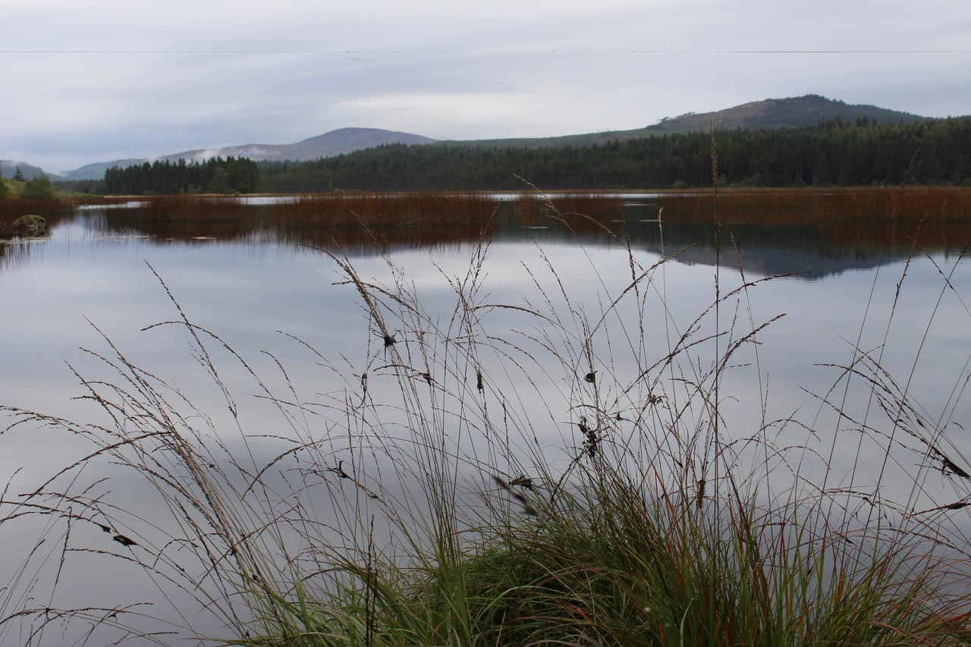
Loch Stroan Thoe Stanning

so we scrambled onto the rail bed and the viaduct. This delighted us with 3 ferns – Asplenium trichomanes maidenhair spleenwort, its smaller companion A. ruta-muraria wallrue and the small tapered fronds of Cystopteris fragilis brittle bladder-fern. Then, among the Hieracium agg hawkweed, one of the group spotted the 3 inch high Chaenorhinum minus small toadflax still in flower – 9 plants in all. This is a VC73 rarity, apparently confined to old rail beds here.

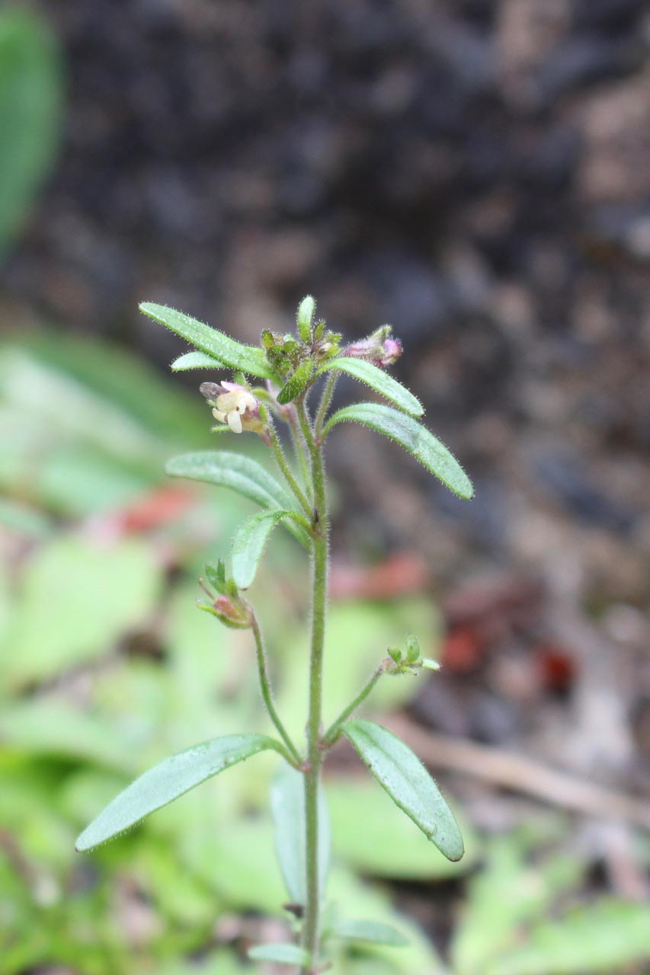
Small toadflax Theo Stanning

And a single small plant of Senecio viscosus sticky groundsel which lived up to its name.

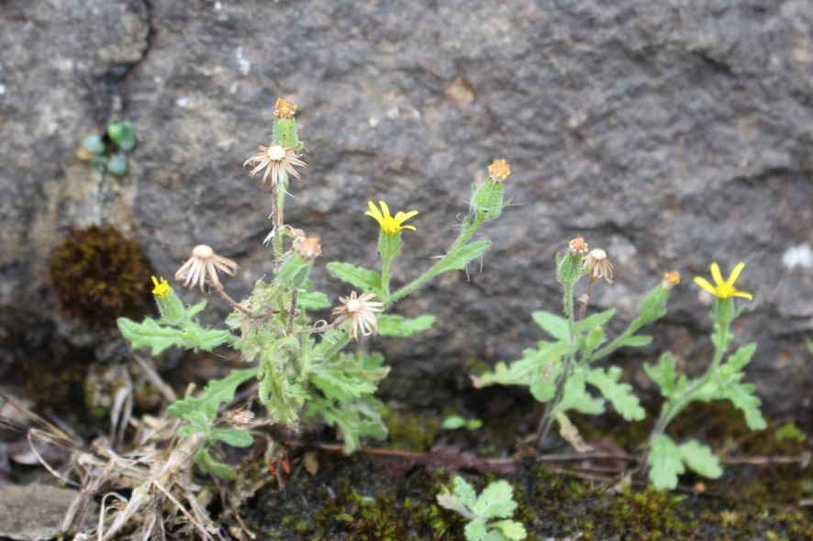
Sticky groundsel Theo Stanning
Further along the rail bed and on some of the slopes of cuttings we found frequent Viola canina heath dog violet, with its more pointed and narrower leaves

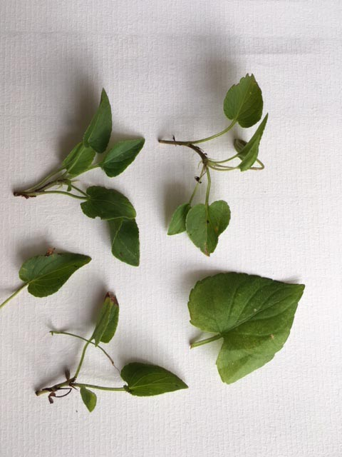
Viola canina leaves left, V. riviniana leaf bottom right David Hawker

– surprisingly the commoner V. riviniana was still in flower. The edges of the rail bed gave us two of the smallest flowering plants in the UK – Radiola linoides allseed and Centunculus minima chaffweed, both unusual and rare in the VC and both flowering.

We spent some time reinforcing the identity of various rushes, both by looking at the pith (or lack of) and the presence of joints in the leaves, as well as the form of the flowering head. Juncus conglomeratus compact rush with its dense head and slightly offset bract; J. articulatus jointed rush with its numerous cross joints in the leaves and shiny black fruits; J. tenuis slender rush with its long bract extending well beyond the flower head, and J. squarrosus heath rush with its deeply channelled leaves and stiff, erect flower/seed spike. In the wetter ground we found frequent Isolepis setacea bristle club rush, the occasional Drosera rotundifolia round-leaved sundew and Pinguicula vulgaris common butterwort. The drier ground had Linaria vulgaris common toadflax while on the way back from Loch Skerrow, Jim spotted a single lanky, flowering plant of Jasione montana sheep’s bit scabious, a species more commonly associated with dry mineral ground at or very near the coast.

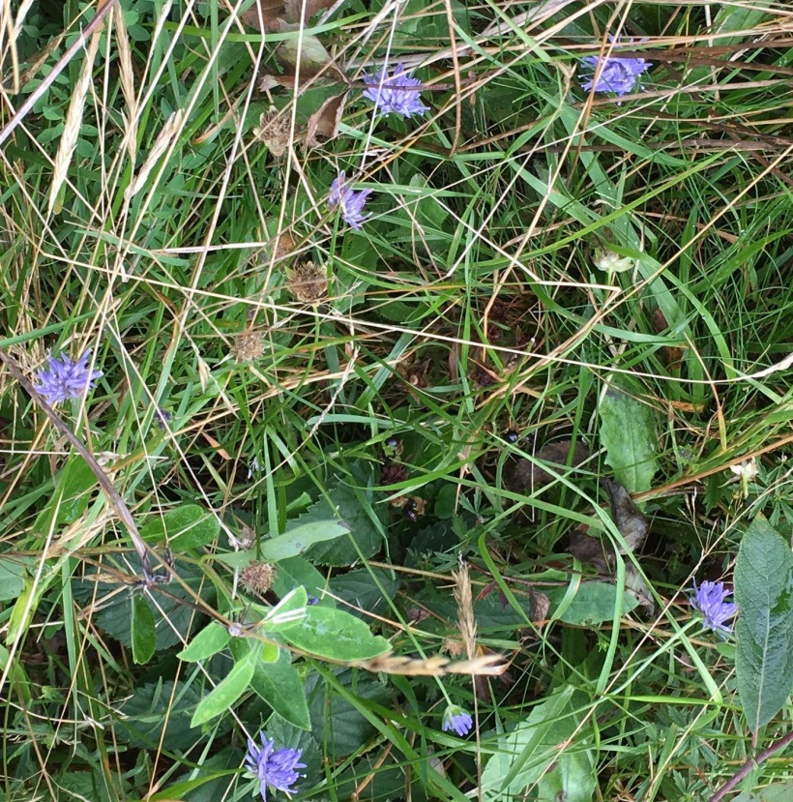
Jasione montana Jan Davidson

Loch Skerrow is set amid acid wet ground so Molinia caerulea purple moor-grass, Trichophorum germanicum deer-grass and Eriophorum vaginatum hare’s-tail cotton-grass were all frequent. The loch itself held very little and again Jim, the only one with wellies, ventured into the water to retrieve a single stem of a small water weed. Debate came to no definite conclusion as to Littorella littoralis shoreweed or one of the Isoetes spp. quillwort.

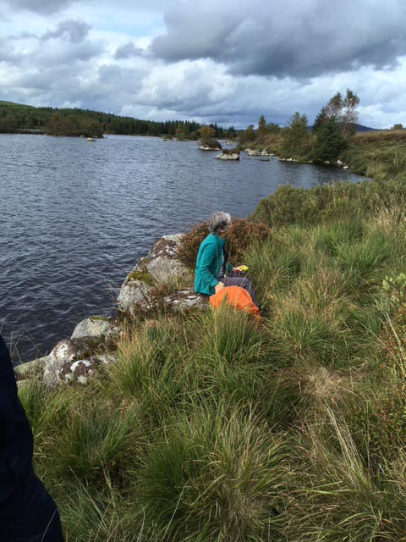
Loch Skerrow David Hawker
Once home, I found the leaf cross-section had 4 circular open channels – I. lacustris quillwort. Despite a binocular search of the islands in the loch for Juniperus communis juniper, I could see nought but Myrica gale bog myrtle and Salix spp, willows.

One of the old rail buildings here held another Asplenium sp. fern, A. scolopendrium hart’s tongue fern, with its undivided leaves. Staying with ferns, we found another 6 species along our route - Phegopteris connectilis beech fern with its two lowest pinnae down-turned; Athyrium filix-femina lady fern with its delicately divided fronds; Oreopteris limbosperma lemon-scented fern with its J-shaped sporangia and slight lemon scent when crushed; and three Dryopteris spp.

The day was only briefly marred by a dreich hour just before and over lunch when midges arrived in droves, but overall it was excellent and added considerably to the VC database - 180 species, with 355 records in all, spread over all 5 monads (range 68-109 per monad). Plus another 3 spp. in a very small part of another monad we briefly crossed. Grateful thanks are due to Val for once again doing all the recording, in what was an exceptionally difficult task. And thank you all for the help in finding and identifying the plants and for the company and of course for the photographs. I hope it wasn’t too demanding in view of the (too) numerous species.

