A day with the RSPB Mersehead, 20th July 2018

The aims of this meeting were:-
To become familiar with the terminology and structure of flowering plants
To use keys to identify plants, specifically the sea lavenders Limonium humile & L. vulgare, and three centauries Centaurium erythraea, C. littorale and C. pulchellum.
To locate where possible the rare or scarce plants, for which there were no documented locations, in the western-most compartment of the reserve (cpt 28)
The first hour or thereabouts was spent indoors with 11 members of the RSPB, staff and volunteers, at the Sulwath Centre covering the first two items.

Once that was done, the party set out for the sand dunes and shell patches of the survey area. Each member had been provided with details of the species (Appendix A), many of which lacked any location; and the locations derived from the BSBI database, Site Condition Monitoring (SCM) undertaken for SNH over the past 15 years, and personal experience of recent site visits (Appendix B). It didn’t take long before we had the first of several of the listed species in sight. First up was the common centaury Centaurium erythraea, admittedly in a very dried up stage – withered leaves and shrivelled buds/flowers, but it was still possible to see the broad ovate leaves of the species and the remains of the basal rosette. In fairly rapid succession, we found the sprawling shoots of the Isle of Man cabbage Coinzya monensis monensis with its rocket salad–like leaves and widely spaced yellow flowers – it turned up frequently, particularly in the sparsely vegetated dunes and amongst the cockle shell areas.

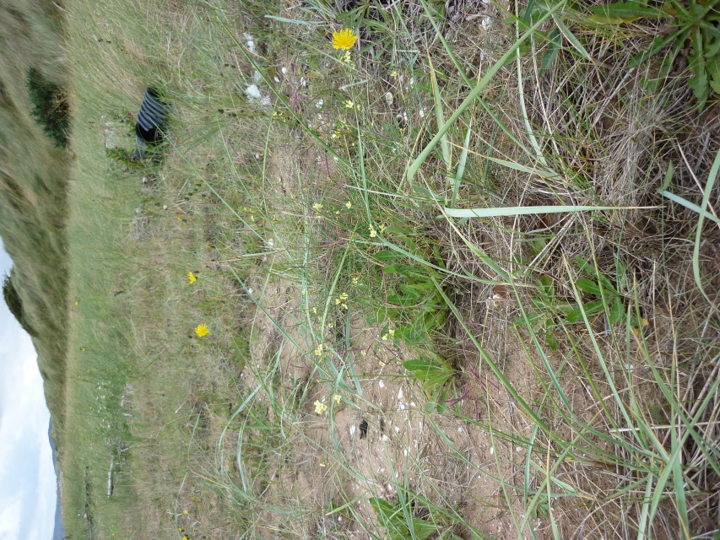
Isle of Man Cabbage Coinzya monensis David Hawker
Here too was about 15 spiny plants of the carline thistle Carlina vulgaris with the dry-looking flower heads, and three shoots, non-flowering, of the round and glossy-leaved sea bindweed Calystegia soldanella.

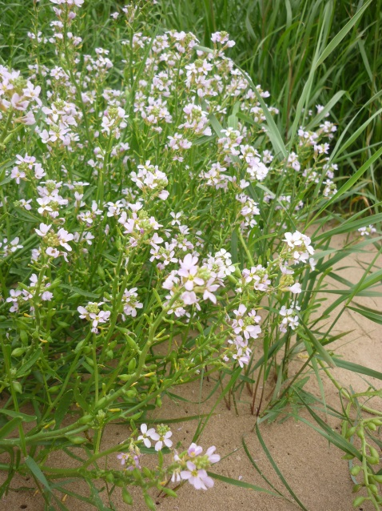
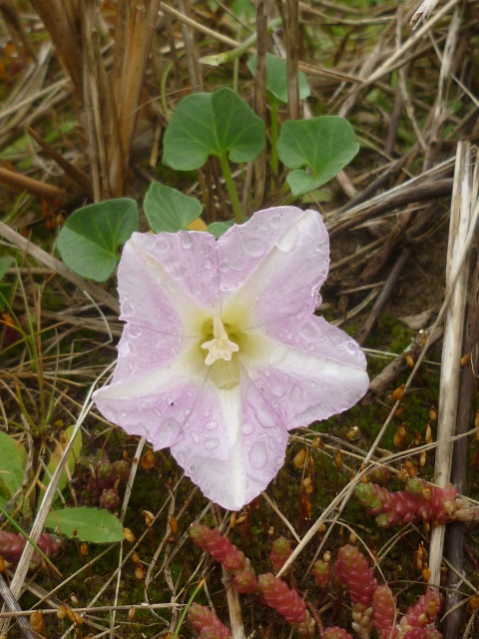

Sea rocket Cakile maritima David Hawker Sea bindweed Calystegia soldanella

Then sea rocket Cakile maritima, pinkish flowers and glossy succulent leaves, on the sandy upper shore just before the marram grass Ammophila arenaria began. A few stout shoots of the wide blue-green leaved sea lyme grass Leymus arenarius occurred here – it’s a species that seems to be spreading slowly along the north Solway shore. Shortly after this Eric spotted the prickly blueish leaves of several sea holly Eryngium maritimum plants; in all there were at least 20 mature flowering plants there.

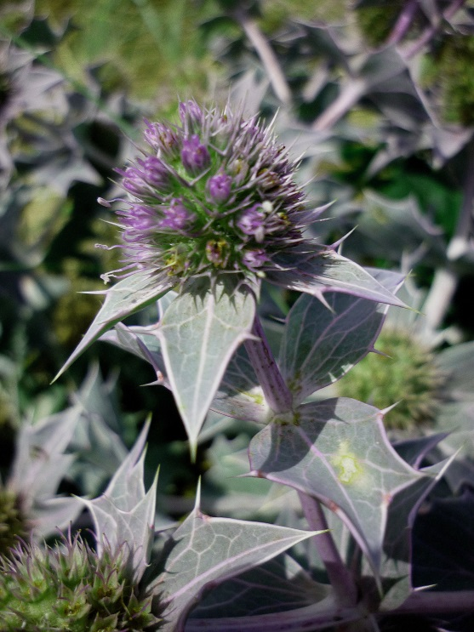
Sea holly Eryngium maritimum David Hawker

Sea spurge Euphorbia paralias occurred in scattered areas nearby, while over a leisurely lunch here we spotted a single shoot of wild pansy Viola tricolor, biting stonecrop Sedum acre which is very bitter and hot to the taste, but largely drying up now, although still showing its reddish succulent leaves, and many plants of the tiny thyme-leaved sandwort Arenaria serpyllifolia.

In the near distance we could see large patches of the purple flowers of sea lavender in the adjoining saltmarsh (merse) and it was to this that we ventured after lunch. All examined had individual spikes with a minimum of 5 and a maximum of 9 flowers, indicating that these were all the common sea lavender L. vulgare. The creek edges had abundant patches of greyish- leaved sea purslane Atriplex portulacoides – more than I could remember from past years. We spent some time keying out a spurrey – whitish flowers with a slight purple tinge to the tips of the petals, large flowers and pointed succulent leaves – greater sea spurrey Spergularia marina. And a whole variety of merse plants – sea aster Aster tripolium, sea plantain Plantago maritima, sea milkwort Glaux maritima, annual sea blite Suaeda maritima, the dreaded cord grass Spartina anglica a tetraploid species which out-competes all other merse plants to form monocultures, parsley water dropwort Oenanthe lachenalii, etc. But no seaside, nor small, centaury, Centaurium littorale and C. pulchellum respectively. A quick search of the brackish pools in another compartment on the way back to the centre, for brackish water crowfoot Ranunculus baudotii and mudwort Limosella aquatica, didn’t reveal any of either species.

At the end of the day we had discovered 74 species in cpts 28 and 20, only 3 discovered out of the 13 listed. Mind you, 2 others were not in the search area. A list of all species recorded and locations of the 3 rare/scarce species will be sent to RSPB shortly, with some indication of population size where possible.

Thanks to all for the day, but it needs a search of the ground nearer the Southwick Burn’s outlet to the sea in cpt 28, to be sure whether the other species are present or absent.

Appendix A: RSPB data

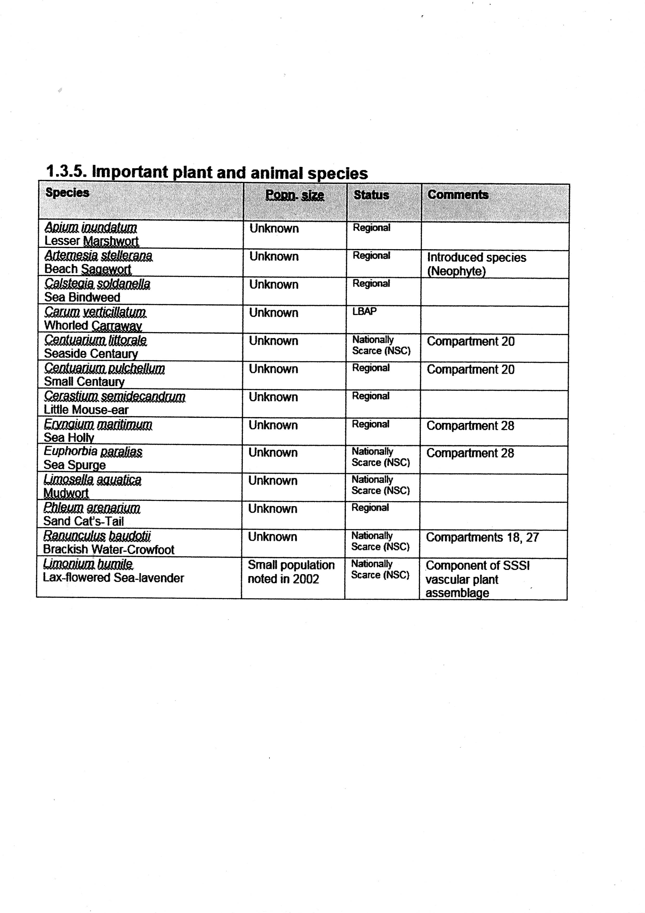

Appendix B: all published data to 2018

