Kippford 19th June 2018

At the invitation of the Kippford Community, we were invited to do a botanical survey of their newly acquired ground, 48 acres or thereabouts, on the outskirts of the village. So 8 of us and 5 members of the Kippford group assembled on site and began. As usual about half an hour later and we were still only metres from the cars. With a final total of over 150 plant species, this report is limited to only a few species! It also doesn’t include anything in the woodland for which we didn’t have sufficient time - that habitat needs a return visit.

The first habitat by the entrance gate was obviously used to feed farm stock and to accumulate piles of soil/manure/compost. And this gave me the first headache as it was covered by masses of a large-leaved and very green goosefoot, which despite the lack of red colour turned out to be red goosefoot Chenopodium rubrum (using Poland’s Vegetative keys at home that evening). Only the second county site in recent years.

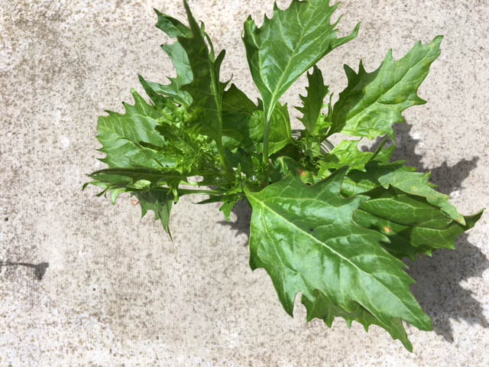
Red goosefoot Chenopodium rubrum David Hawker

The surrounding ground was obviously heavily poached with large areas of bare ground in which we found other ruderal species – heath cudweed Gnaphalium uliginosum with its grey-green strap-shaped leaves; the prostrate but common knotgrass Polygonum aviculare with smaller branch leaves than stem leaves (termed heterophyllous); small patches of the round-leaved water crowfoot Ranunculus omiophyllus; and water pepper Persicaria hydropiper with its distinctive hot peppery taste.

Then over to the first boggy area centred on a small drainage channel from a spring. This turned up a variety of species including star sedge Carex echinata, common sedge C. nigra with its black glumes and very narrow leaves; carnation sedge C. panicea of glaucous grey-green leaves; the three buttercups - creeping Ranunculus repens, meadow R. acris (which is what that small-flowered plant turned out to be), lesser spearwort R. flammula; whorled caraway Carum verticillatum in one relatively small patch, with its finely divided leaves looking a bit like a bright green yarrow Achillea millefolium but less compact. The area turned out to be a mix of acid ground (e.g. star sedge) and more neutral areas, going from waterlogged, with brown watercress Nasturtium microphyllum, with its narrow sickle-shaped fruits – so called as the leaves turn brown in autumn unlike the commoner species which stays green all year-round – to damp slopes with rushes Juncus spp..

The grassland beyond that gave the impression of being semi-improved ground with very occasional rye grass Lolium perenne and frequent crested dogstail Cynosurus cristatus with its one-sided flower spike and abundant Yorkshire fog Holcus lanatus. But amongst this we found oval sedge Carex leporina, an indicator of damp + neutral ground; and meadow vetchling Lathyrus pratensis just opening its yellow pea-shaped flowers on the ends of straggling stems.

There were strips of woodland, that in the NW corner being particularly interesting with several obviously veteran ash Fraxinus excelsior of large girth and height

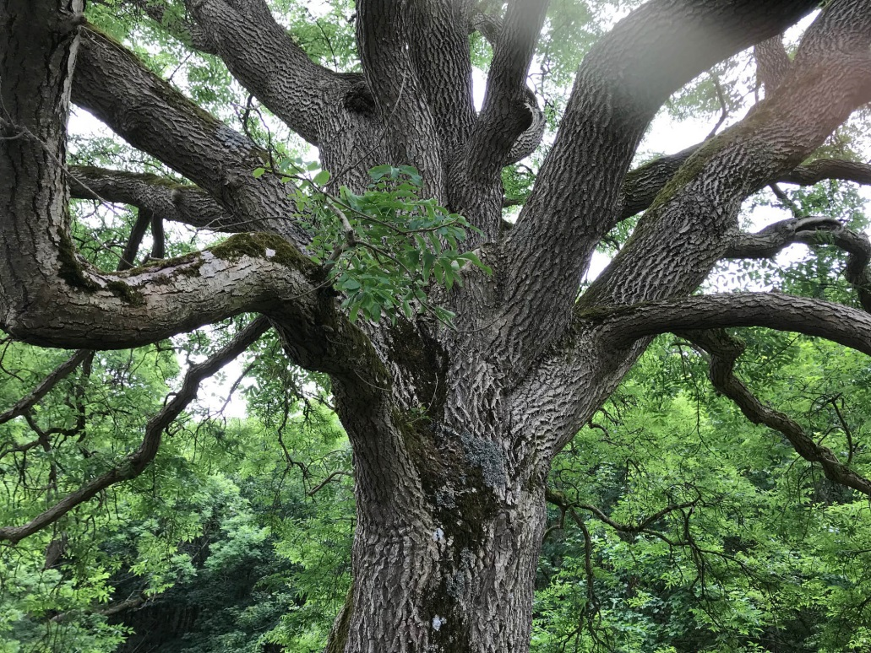
“The eyes have it” veteran ash tree Theodora Stanning

sheltering two Ancient Woodland Indicator species, Town hall clock or moschatel Adoxa moschatellina and wood speedwell Veronica montana with hairs all around the stems. There were scattered common dog violets Viola riviniana and bluebell Hyacinthoides non-scripta. Beyond this were two very old wild apples Malus sylvestris and also scattered gorse Ulex europaeus and broom Cytisus scoparius scrub, along with hawthorn Crataegus monogyna. We didn’t get into the adjoining larger area of woodland.

Then we surveyed several granite rock outcrops before settling on one of them for lunch. English stonecrop Sedum anglicum, mouse-ear hawkweed Pilosella officinarum in flower, sheep’s sorrel Rumex acetosella, parsley piert Aphanes arvensis, the tiny pill sedge Carex pilulifera with its arched leaves, and several small patches of the yellow-flowered, less acid-loving, lady’s bedstraw Galium verum were noted, while over lunch, both fine-leaved fescue Festuca filiformis and sheep’s fescue F. ovina were found on the lunch-time outcrop. Post-lunch and we explored yet another wet area, again with marsh pennywort Hydrocotyle vulgaris, a low-growing, round-leaved creeping plant which like nutrient rich sites. The drier, but still damp slopes held both oval sedge and pale sedge Carex pallescens, with its pale green leaves and stem but more significantly, a crinkled base to the bract beneath the flower spike. All of these like high nutrient damp soils, as does the pink-flowered ragged robin Silene flos-cuculi. And noted the spring and well there

During the morning there were various discussions about the wet/damp areas – what to do with them, how to manage them - grassland management, woodland management and supplementary planting – all of which revealed the considerable expertise available within the group.

A quick walk around the mixed woodland strip, looking at a white flowered rose with strongly curved prickles and a slight pink tinge to the stem, which I think is Sherard’s downy rose Rosa sherardii
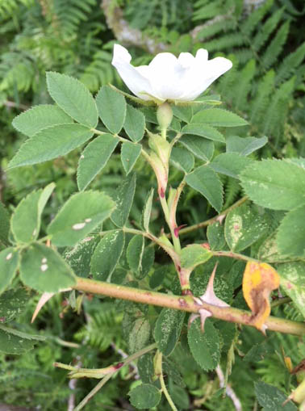
Rosa sherardii David Hawker
and finally deciding that the large mature larch was European larch Larix europaea with longish cones and scales that weren’t curved back on themselves. Under one of the trees I found wood stitchwort Stellaria nemorum, like a larger, more round-leaved version of ordinary chickweed S. media but less common and it is another woodland indicator species. A walk back towards the cars, stopping to discuss another deep well hidden from view behind some willows and surrounded by yet another marshy area with more marsh pennywort. Previous discussions beside the pony paddock related to various birch species, native and otherwise, to be considered for planting – their merits, cost and source.

Those species shown above in bold are considered to be of high conservation value for this site.

Lastly, Peter Robinson produced a list of non-plant species on site which included three damselflies, four butterflies and 2 moths, 5 bumblebees, 13 birds, and several other species. A full list of species, including the plants, is available from me.

Thanks to all who attended what turned out to be a very interesting and ecologically high value (in terms of conservation) site.

The next meeting will be to Arbigland, south of Kirkbean, at NX 98 57. Meet at the Powillimount car park (NX 989 563) at 10 a.m. on Thursday 5th July (note change of date please) when we will be searching for the orchid broad-leaved helleborine Epipactis helleborine in the woodland strips – the only known VC73 site. It’s almost flat walking, mainly along minor roads or estate tracks.

