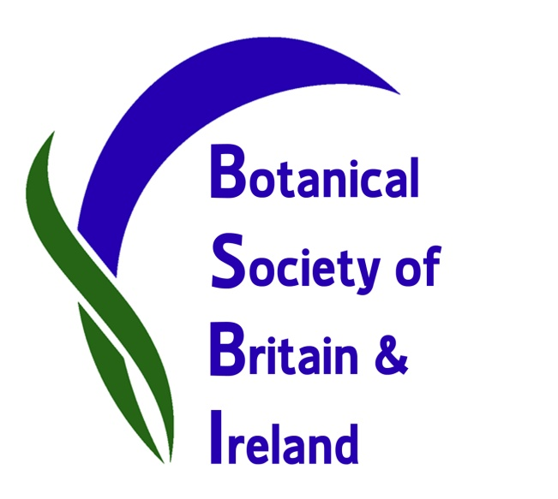

Botanical Society has new name but same aims.

BSBI is the leading society promoting the study, enjoyment and understanding of the wild plants of Britain and Ireland, and has been in existence since 1836 under several different names, most recently as the Botanical Society of the British Isles.

The society’s President, Ian Denholm, said: “BSBI trustees have been working to put the society on a footing which is more appropriate, legally and financially, to the way we operate in the 21st century and the sort of contract work the society is increasingly asked to do. So, we remain a charity but are becoming a company limited by guarantee, and this process necessitates a name change”.

BSBI members voted last year to adopt the name Botanical Society of Britain & Ireland. Ian said: “This also flags up the important contribution that our Irish members make to the society”.

Dr Maria Long, BSBI Irish Officer, said: “We just enjoyed a very successful AGM in Killarney for BSBI’s Irish botanists and guests - all delighted at the name change!”

But although our name may change slightly, our aims do not: BSBI aims to promote the study, understanding and enjoyment of our vascular plants and charophytes; and to use our society's combined knowledge, expertise and enthusiasm to help support the conservation of wild plants throughout Britain and Ireland.

Find out more about BSBI at www.bsbi.org.uk

-------------------------------------------------------------------------------------------------------
Louise Marsh Dr Maria Long
BSBI Publicity & Outreach Officer BSBI Irish Officer
Email: publicity@bsbi.org.uk Email: maria.long@bsbi.org.uk

