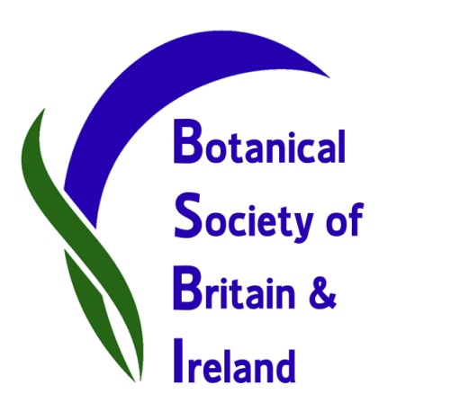
BSBI Plant Hunt finds 221 plants in flower during mild New Year weather
Botanists have been braving the winter weather for the third year running to find out which wild flowers were in bloom over the New Year period. Results are now in and an amazing 221 species were recorded flowering, with our members reporting back from widespread localities across Britain and Ireland. This flowering is attributed to the mild, if stormy, weather, which has meant that many species have not been frosted, so have continued to flower from the autumn.
We asked botanists to spend up to three hours listing any wild plants and garden escapes in flower, but not species planted in gardens. Around 70 BSBI members responded to the call, and members of the public also contributed records via our Facebook and Twitter pages. We received 48 lists of plants in flower from 32 counties across Britain and Ireland: from Cornwall to Orkney and from Suffolk to Anglesey and Wexford in Ireland. The records covered a wide range of plants and most botanists were surprised at how many species they found in flower. Our results were:
- 221 species in flower, of which:
- 164 species are native to Britain and Ireland (about 10% of our native wild flowers), and
- 57 species are non-native or escaped from gardens.
The most commonly recorded species were groundsel (40 out of 48 records = 83%), daisy (81%) and dandelion (69%) which are well known to flower during the winter. Other species recorded in over half of the lists were Smooth Sowthistle, Annual Meadow Grass, Chickweed, Shepherd’s Purse, Dwarf Spurge, Common Field-speedwell and Red Deadnettle. Gorse, well known to flower all year, was recorded in 44% of the lists.
In contrast, another 104 species were only recorded once; these are the more unusual occurrences of plants flowering out of season.
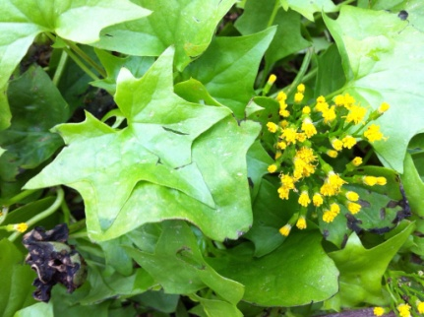
German-ivy in flower in Cornwall on 29th December 2013 (Image: Elise O’Donnell)
The most species found flowering during any one survey were jointly in Cardiff and Leicester (66 in flower). 15 lists had more than 30 species recorded flowering whilst 14 had fewer than 10 species. In general, more species were recorded in the south compared to the north, and more species were recorded in towns and cities, where there are more weeds and the temperatures are slightly warmer. The least number flowering (2 species) were recorded in the Outer Hebrides and Central Wales. Amongst the interesting records were: German-ivy flowering in Cornwall; a first record of Round-leaved Crane’s-bill in Leicester; and a second record of Musk Stork’s-bill in Lincolnshire.
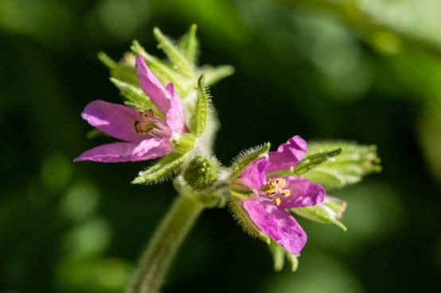
Musk Stork’s-bill in flower in Lincolnshire on 2nd January 2014 (Image: Sarah Lambert).
This year’s Plant Hunt was co-ordinated by Tim Rich in Cardiff and Sarah Whild in Shrewsbury. Tim, who also collated all the records, said “The number of botanists who contributed was fantastic - the New Year’s Plant Hunt has really taken off this year! What surprised us all was the sheer number of different species recorded in flower”.
Sarah said “For areas with comparable surveys, this year had 40% more species flowering than last year. We started the project on New Year’s Day 2012, when 63 different species were seen flowering prolifically in Cardiff during an exceptionally mild winter. Last year, the winter was more typical and notably fewer species were recorded.”
BSBI President Ian Denholm said “Records of which plants are in flower at this time of year will fill an important gap in our knowledge of plant phenology and how this is affected by both climatic conditions and recent weather. Botanists don’t usually go out at this time of year, but our members really enjoyed this year’s Plant Hunt and it has yielded some valuable data; we look forward to running it again next year.”
Notes:
1. See our News Blog for Plant Hunt records and more images (some available at high res.).
2. BSBI is on Twitter @BSBIbotany – see Plant Hunt records under hashtag #BSBIPlantHunt
3. More Plant Hunt records, images and stories on our Facebook page
4. This year’s Plant Hunt ran from 28th December 2013 - 5th January 2014 to allow for bad weather.
Contacts:
BSBI Publicity & Outreach Officer Louise Marsh: for more images and information about BSBI.
Email: louise.marsh@bsbi.org Telephone: 07971 2972 529
Plant Hunt Co-ordinator Tim Rich: for information on plants recorded and national distributions.
Email: tim_rich@sky.com Telephone: 029 222 11690; mobile 07799620035
President Ian Denholm: for more information on plant phenology. Email: i.denholm@herts.ac.uk

