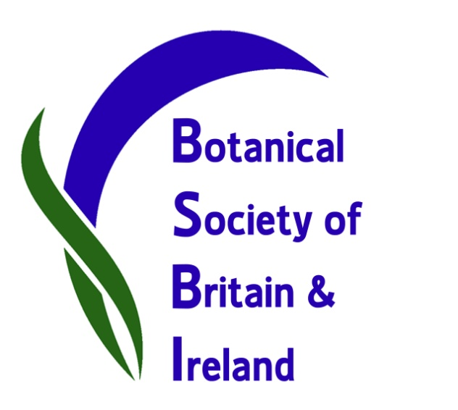

BSBI’s third New Year’s Day Plant Hunt: which plants are in flower now?
The call has gone out for the third successive year: British and Irish botanists are encouraged to get out over the holiday in their local area to record which wild or naturalised plants are in flower on New Year’s Day. But this year – to accommodate bad weather, visiting relatives and hangovers – our plant-hunters have been allowed to pick any three-hour time-slot between 28th December and 1st January.
The idea of the Plant Hunt is to record any wild plants seen in flower during this period, but not garden plants, unless naturalised – that is, established and surviving in the wild without human intervention.
Records should be emailed for collation to BSBI botanist Tim Rich, who is co-ordinating this year’s Plant Hunt. BSBI President Ian Denholm is encouraging botanists to contribute and said “Records of which plants are in flower at this time of year will fill an important gap in our knowledge of plant phenology and how this is affected by both climatic conditions and recent weather. We look forward to botanists reporting their findings - I’m sure there will be some surprises in terms of species able to produce flowers at this time of year. It will also be interesting to see variation across Britain and Ireland”.
Records and photographs are flooding in already and can be viewed on our Facebook page and on Twitter and on our news Blog so you can see how we are getting on – or contact your local botany group or BSBI County Recorder here and find out what is happening locally.

Photo opportunity: botanists out recording plants at various locations around the country.
Contact BSBI Publicity & Outreach Officer Louise Marsh for more information:
Email: louise.marsh@bsbi.org Telephone: 07971 2972 529
Contact Plant Hunt Co-ordinator Tim Rich. Email: tim_rich@sky.com
Contact BSBI President Ian Denholm. Email: i.denholm@herts.ac.uk

