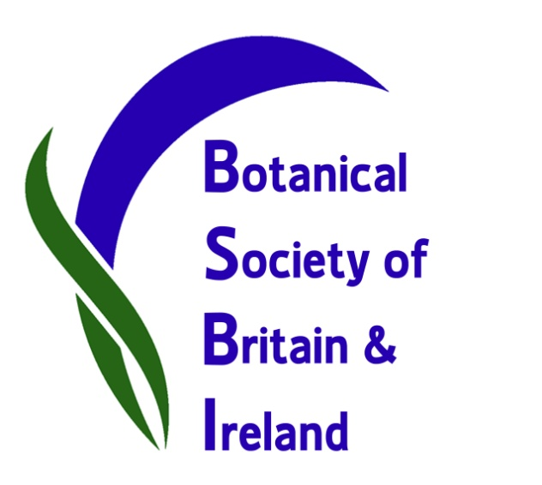

A huge success: BSBI’s third New Year’s Plant Hunt.
This year’s Plant Hunt is proving a huge success – botanists all over Britain and Ireland have been out over the holidays to record which wild or naturalised plants were in flower in their local areas. From Guernsey to Orkney, from Norfolk via Cardiff to Co. Wexford, plant records have been flooding in and are already being collated by Plant Hunt Co-ordinator Dr Tim Rich.
The idea of BSBI’s annual Plant Hunt is to record any wild plants seen in flower around New Year’s Day, but not garden plants, unless naturalised – that is, established and surviving in the wild without human intervention.
Tim Rich said “The response has been amazing this year! Over 40 lists have been submitted so far, from all over the country: from Devon to the Outer Hebrides, and Anglesey to Suffolk. Around 200 plants have already been recorded flowering, the majority of which are native species to Britain. The most frequently recorded species so far is Groundsel Senecio vulgaris which has been seen flowering in most places. Most plants in flower are “weeds” and a few garden escapes, but several seashore plants are still flowering and some calcareous grassland species. We have also had several unusual records, including two ‘firsts’ for a county - Guernsey Fleabane Conyza sumatrensis new to Lincolnshire and Round-leaved Crane's-bill Geranium rotundifolium new to Leicestershire.”
Records and photographs can already be viewed on our Facebook page and on Twitter and on our news Blog so you can see how we are getting on – or contact your local botany group or BSBI County Recorder here and find out which plants were recorded locally.

Images available: plants seen and also botanists out recording plants at various locations around the country.
Contact BSBI Publicity & Outreach Officer Louise Marsh for images and more information:
Email: louise.marsh@bsbi.org Telephone: 07971 2972 529
Contact Plant Hunt Co-ordinator Tim Rich. Email: tim_rich@sky.com

