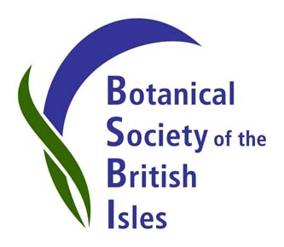
BSBI wins Best Stand Award (Conservation) at Birdfair 2013.
The BSBI stand at Birdfair 2013 has been awarded Best Stand (Conservation). We offered displays, presentations and a guest lecture by our new President, Ian Denholm, all aimed at transmitting something of BSBI’s enthusiasm for British botany to the Birdfair visitors. Our volunteers are delighted that their hard work paid off and the Birdfair judges awarded us first prize. Second prize went to the RSPB stand.
We spoke to hundreds of visitors to the BSBI stand, which featured plant displays (provided by University of Leicester Botanic Garden) showing the plants associated with habitats which support iconic British birds, like corncrake, lapwing and some of our upland raptors. We also tried to find novel ways to show people how we identify plants and some of the practical advantages of knowing your botany. And we showed people how they could get involved in their local area and record the plants they saw, making a valuable contribution to our ongoing scientific work and feeding into the BSBI database - one of the world’s largest databases of biological records, which help inform national policy-makers and the international scientific community.
The Best Stand Award (Conservation) was presented to us by Martin Davies of RSPB: they co-organise the Birdfair with Leicestershire and Rutland Wildlife Trust. This year, the Birdfair celebrated its 25th anniversary, so it is a particular honour for our stand to have won first prize in such a milestone year.
BSBI looks forward to working even more closely in future with partner organisations like RSPB and the Centre for Ecology and Hydrology, who also contributed to the BSBI stand at Birdfair 2013.
See our Publicity Blog for images and to find out more about BSBI at Birdfair and other outreach events.
Contact Louise Marsh, BSBI Publicity & Outreach Officer, for more information or to arrange an interview with Ian Denholm, BSBI President.
Email: publicity@bsbi.org.uk
Mobile number: 0797 197 2529
Publicity Blog: http://bsbipublicity.blogspot.co.uk/
IMAGE CAPTION: BSBI volunteer Rachel Benskin accepts the award for Best Stand (Conservation) from Martin Davies of RSPB, Co-organiser of Birdfair 2013.

