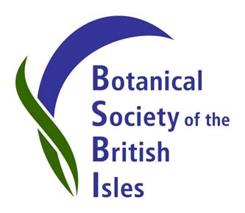
New BSBI video is now available on YouTube.
A short video (2:24) is now available of the BSBI Team in action on the award-winning BSBI stand at Birdfair 2013, held last weekend at Rutland Water.
The video shows our volunteers – from local members to our new President, Ian Denholm – guiding Birdfair visitors around the various plant displays on the stand and telling them about BSBI. Ian explains how BSBI can help people develop their identification skills and how to get involved locally in botanical conservation, and two local group co-ordinators talk about what’s happening in their areas. Our members record the plants they see, making a valuable contribution to our ongoing scientific work and feeding into the BSBI database - one of the world’s largest databases of biological records, which help inform national policy-makers and the international scientific community.
The Birdfair judges awarded BSBI First Prize in the category Best Stand (Conservation) 2013, so take a look at the new video on YouTube and see if you agree with their decision!
View the video here: https://www.youtube.com/channel/UCsxhHQYHSmcrggSiXj_rOAA
See our Publicity Blog for images and to find out more about BSBI at Birdfair and other outreach events.
Contact Louise Marsh, BSBI Publicity & Outreach Officer, for more information or to arrange an interview with Ian Denholm, BSBI President.
Email: publicity@bsbi.org.uk
Mobile number: 0797 197 2529
Publicity Blog: http://bsbipublicity.blogspot.co.uk/

