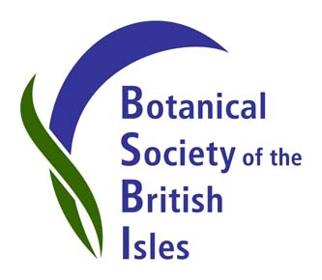
Press Release, embargoed until 2.00 pm on Wednesday, 12th June, 2013.
BSBI welcomes our new President.
On 12th June, Dr. Ian Denholm becomes the new President of the Botanical Society of the British Isles.
As Chair of BSBI’s Meetings Committee, Ian has been a driving force behind the society’s recent initiatives in publicity and outreach. His presentation to journalists and conservationists, at the May 2013 launch of the State of Nature report, showcased BSBI as a key partner in this new coalition of conservation and research organisations supporting British wildlife. He also co-ordinated the organisation of last year’s highly successful Mapping Conference, held at the Royal Botanic Garden, Edinburgh.

Ian spent thirty years as an agricultural scientist at Rothamsted Research, heading their Plant and Invertebrate Ecology Department, while remaining very active in field botany and within BSBI. As BSBI’s co-referees for Orchids, Ian and Professor Richard Bateman (Kew) are the botanical experts to whom the society’s 3,000 members, and the wider botanical community, turn to for advice on correct identification of these difficult plants. He now combines a Visiting Scientist role at Rothamsted with a part-time academic position at the University of Hertfordshire.
Ian hopes to build on the excellent contributions of his predecessor, Ian Bonner, and help reshape the society as it reconsiders its role in 21st century botany. He is particularly keen to see greater recognition and exploitation of BSBI’s scientific resources. The society is one of the world’s leading contributors of biological records and, as Ian Denholm points out, “BSBI’s structured species’ recording and mapping projects revolutionised approaches to monitoring our flora and fauna, and have had a lasting, international influence on how wildlife is recorded, mapped and monitored. The success of these projects is due to the dedication, expertise and enthusiasm of our thousands of members, past, present and future”.
Louise Marsh
BSBI Publicity & Outreach Officer
- Find out more about Ian and what BSBI does at http://www.bsbi.org.uk/publicity.html
- To arrange an interview with Ian Denholm, or for higher-resolution images, please contact Louise Marsh, BSBI Publicity & Outreach Officer. Email: publicity@bsbi.org.uk Telephone: 07971 972 529.
- Image 1 legend: Ian Denholm and Sir David Attenborough at Rothamsted, 2008.
- Image 2 legend: Ian Denholm at the State of Nature launch. Natural History Museum, London, 22nd May, 2013. Photo: L.Marsh.

