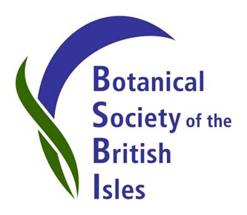

Working together for wildlife: BSBI and CEH at Birdfair 2013

The Botanical Society of Britain and Ireland’s stand at this year’s Birdfair, which opens tomorrow Friday, 16th August at Rutland Water, includes contributions from the Centre for Ecology & Hydrology. We demonstrate how BSBI and CEH are sharing resources to record the wildlife that grows, crawls or flies in Britain and Ireland, and how this is changing over time.

BSBI’s stand is offering three days of plant displays, botanical exhibits and wildflower identification demonstrations. On Saturday at 4.30pm in the Anglian Water Birdwatching Centre, BSBI’s new President, Ian Denholm, a lifelong birder and botanist, will present a lecture entitled ‘Botany for Birders’, highlighting similarities, differences and interactions between birding and botanising.

Ian Denholm said “BSBI has a long history of scientific collaboration with CEH and we are about to strengthen these links through an agreement to safeguard and consolidate our unique botanical datasets. We look forward to sharing more platforms at Birdfair and related events in the future”.

BSBI and CEH have collaborated at exhibitions before. In 2012, CEH invited us to join them at Gardeners’ World Live. BSBI offered plant ID demonstrations and we hope we made a positive contribution towards the CEH stand being awarded highly commended by the RHS judges.

David Roy, Head of the Biological Records Centre (BRC) at CEH said “BRC came into existence almost 50 years ago to help safeguard the data underlying BSBI’s first Atlas of the British Flora. BRC and BSBI have collaborated closely ever since to reveal major changes in our flora. We are delighted to share this opportunity to promote biological recording.”

The annual Birdfair attracts birdwatchers from all over the world, and up to 20,000 visitors are expected at this year’s event, which runs from 16th to 18th August. BSBI and CEH are looking forward to meeting fellow wildlife enthusiasts on Stand 57, Marquee 1.

More info about Birdfair here:

http://www.birdfair.org.uk/

To find out more about BSBI and CEH at Birdfair, contact:

Louise Marsh, BSBI Publicity & Outreach Officer, email: publicity@bsbi.org.uk

Jodey Peyton, CEH Field Ecologist, email: joyt@ceh.ac.uk

